1 run......

training 1 epoch...

9.328075885772705 seconds used......

1 training finished! average train loss: 2.474020004272461

total clf loss: 39.53696322441101 total adv loss: 24.763878226280212

evaluating...

Confusion matrix, without normalization

[[ 0 33 8]

[ 0 41 54]

[ 0 265 449]]

Normalized confusion matrix

[[0. 0.80487805 0.19512195]

[0. 0.43157895 0.56842105]

[0. 0.37114846 0.62885154]]

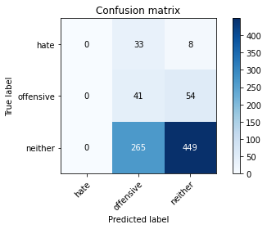

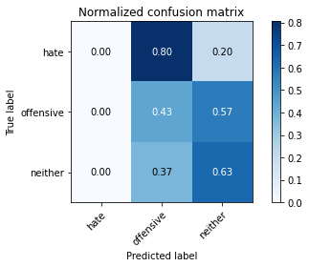

/opt/conda/lib/python3.7/site-packages/sklearn/metrics/_classification.py:1245: UndefinedMetricWarning: Precision and F-score are ill-defined and being set to 0.0 in labels with no predicted samples. Use `zero_division` parameter to control this behavior.

_warn_prf(average, modifier, msg_start, len(result))

/opt/conda/lib/python3.7/site-packages/sklearn/metrics/_classification.py:1245: UndefinedMetricWarning: Precision and F-score are ill-defined and being set to 0.0 in labels with no predicted samples. Use `zero_division` parameter to control this behavior.

_warn_prf(average, modifier, msg_start, len(result))

/opt/conda/lib/python3.7/site-packages/sklearn/metrics/_classification.py:1245: UndefinedMetricWarning: Precision and F-score are ill-defined and being set to 0.0 in labels with no predicted samples. Use `zero_division` parameter to control this behavior.

_warn_prf(average, modifier, msg_start, len(result))

precision recall f1-score support

hate 0.00 0.00 0.00 41

offensive 0.12 0.43 0.19 95

neither 0.88 0.63 0.73 714

accuracy 0.58 850

macro avg 0.33 0.35 0.31 850

weighted avg 0.75 0.58 0.64 850

average eval_loss: 0.8656525604946669, accuracy: 0.5764705882352941

training 2 epoch...

9.381466388702393 seconds used......

2 training finished! average train loss: 2.0940711994965873

total clf loss: 33.007555186748505 total adv loss: 21.189503878355026

evaluating...

Confusion matrix, without normalization

[[ 0 30 11]

[ 0 76 19]

[ 0 232 482]]

Normalized confusion matrix

[[0. 0.73170732 0.26829268]

[0. 0.8 0.2 ]

[0. 0.32492997 0.67507003]]

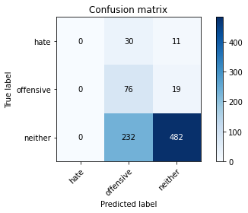

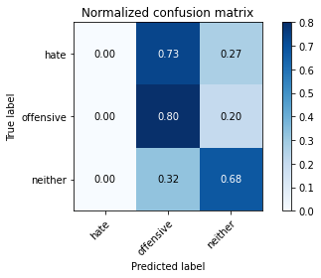

/opt/conda/lib/python3.7/site-packages/sklearn/metrics/_classification.py:1245: UndefinedMetricWarning: Precision and F-score are ill-defined and being set to 0.0 in labels with no predicted samples. Use `zero_division` parameter to control this behavior.

_warn_prf(average, modifier, msg_start, len(result))

/opt/conda/lib/python3.7/site-packages/sklearn/metrics/_classification.py:1245: UndefinedMetricWarning: Precision and F-score are ill-defined and being set to 0.0 in labels with no predicted samples. Use `zero_division` parameter to control this behavior.

_warn_prf(average, modifier, msg_start, len(result))

/opt/conda/lib/python3.7/site-packages/sklearn/metrics/_classification.py:1245: UndefinedMetricWarning: Precision and F-score are ill-defined and being set to 0.0 in labels with no predicted samples. Use `zero_division` parameter to control this behavior.

_warn_prf(average, modifier, msg_start, len(result))

precision recall f1-score support

hate 0.00 0.00 0.00 41

offensive 0.22 0.80 0.35 95

neither 0.94 0.68 0.79 714

accuracy 0.66 850

macro avg 0.39 0.49 0.38 850

weighted avg 0.82 0.66 0.70 850

average eval_loss: 0.7713352060595224, accuracy: 0.6564705882352941

training 3 epoch...

9.33812403678894 seconds used......

3 training finished! average train loss: 1.7665714340077505

total clf loss: 28.17764937877655 total adv loss: 17.709460869431496

evaluating...

Confusion matrix, without normalization

[[ 0 25 16]

[ 0 68 27]

[ 5 193 516]]

Normalized confusion matrix

[[0. 0.6097561 0.3902439 ]

[0. 0.71578947 0.28421053]

[0.0070028 0.27030812 0.72268908]]

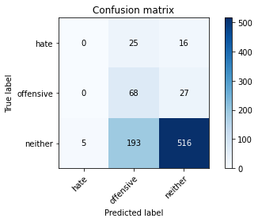

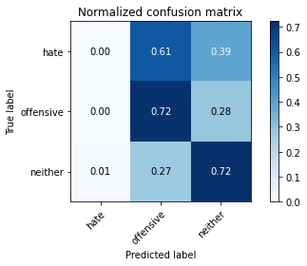

precision recall f1-score support

hate 0.00 0.00 0.00 41

offensive 0.24 0.72 0.36 95

neither 0.92 0.72 0.81 714

accuracy 0.69 850

macro avg 0.39 0.48 0.39 850

weighted avg 0.80 0.69 0.72 850

average eval_loss: 0.7290922678833784, accuracy: 0.6870588235294117

training 4 epoch...

9.3413405418396 seconds used......

4 training finished! average train loss: 1.2882479793495603

total clf loss: 21.775560081005096 total adv loss: 12.300683379173279

evaluating...

Confusion matrix, without normalization

[[ 3 28 10]

[ 5 80 10]

[ 21 261 432]]

Normalized confusion matrix

[[0.07317073 0.68292683 0.24390244]

[0.05263158 0.84210526 0.10526316]

[0.02941176 0.36554622 0.60504202]]

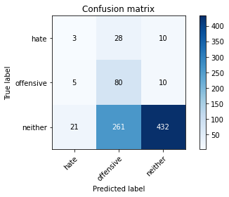

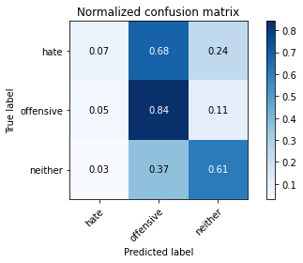

precision recall f1-score support

hate 0.10 0.07 0.09 41

offensive 0.22 0.84 0.34 95

neither 0.96 0.61 0.74 714

accuracy 0.61 850

macro avg 0.43 0.51 0.39 850

weighted avg 0.83 0.61 0.67 850

average eval_loss: 0.88635178395482, accuracy: 0.6058823529411764

training 5 epoch...

9.33382248878479 seconds used......

5 training finished! average train loss: 0.6770295211010509

total clf loss: 15.027815088629723 total adv loss: 4.672623798483983

evaluating...

Confusion matrix, without normalization

[[ 12 22 7]

[ 12 70 13]

[ 56 213 445]]

Normalized confusion matrix

[[0.29268293 0.53658537 0.17073171]

[0.12631579 0.73684211 0.13684211]

[0.07843137 0.29831933 0.6232493 ]]

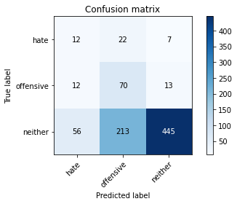

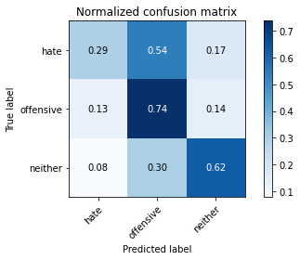

precision recall f1-score support

hate 0.15 0.29 0.20 41

offensive 0.23 0.74 0.35 95

neither 0.96 0.62 0.75 714

accuracy 0.62 850

macro avg 0.45 0.55 0.43 850

weighted avg 0.84 0.62 0.68 850

average eval_loss: 0.8871205562595711, accuracy: 0.62

training 6 epoch...

9.270599365234375 seconds used......

6 training finished! average train loss: 0.36771032007204163

total clf loss: 10.580051228404045 total adv loss: 1.328760149073787

evaluating...

Confusion matrix, without normalization

[[ 10 24 7]

[ 10 78 7]

[ 60 251 403]]

Normalized confusion matrix

[[0.24390244 0.58536585 0.17073171]

[0.10526316 0.82105263 0.07368421]

[0.08403361 0.35154062 0.56442577]]

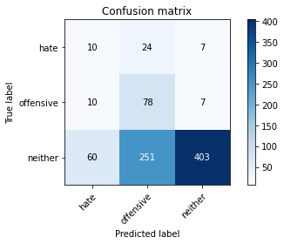

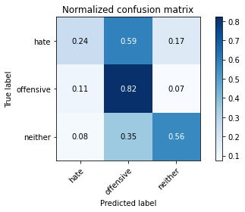

precision recall f1-score support

hate 0.12 0.24 0.17 41

offensive 0.22 0.82 0.35 95

neither 0.97 0.56 0.71 714

accuracy 0.58 850

macro avg 0.44 0.54 0.41 850

weighted avg 0.84 0.58 0.65 850

average eval_loss: 1.1259533187677695, accuracy: 0.5776470588235294

training 7 epoch...

9.446641683578491 seconds used......

7 training finished! average train loss: 0.24078958119369215

total clf loss: 7.61183338239789 total adv loss: 0.5282957918825559

evaluating...

Confusion matrix, without normalization

[[ 18 16 7]

[ 18 62 15]

[ 83 186 445]]

Normalized confusion matrix

[[0.43902439 0.3902439 0.17073171]

[0.18947368 0.65263158 0.15789474]

[0.1162465 0.2605042 0.6232493 ]]

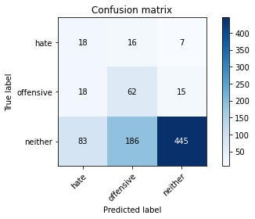

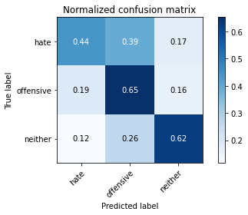

precision recall f1-score support

hate 0.15 0.44 0.23 41

offensive 0.23 0.65 0.35 95

neither 0.95 0.62 0.75 714

accuracy 0.62 850

macro avg 0.45 0.57 0.44 850

weighted avg 0.83 0.62 0.68 850

average eval_loss: 1.0149842966781106, accuracy: 0.6176470588235294

training 8 epoch...

9.238342046737671 seconds used......

8 training finished! average train loss: 0.2223443416878581

total clf loss: 6.211008958518505 total adv loss: 0.8966936638171319

evaluating...

Confusion matrix, without normalization

[[ 16 20 5]

[ 17 72 6]

[ 99 217 398]]

Normalized confusion matrix

[[0.3902439 0.48780488 0.12195122]

[0.17894737 0.75789474 0.06315789]

[0.13865546 0.30392157 0.55742297]]

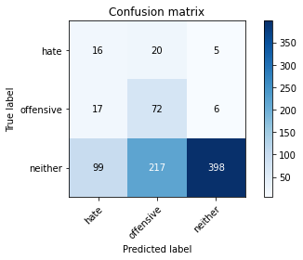

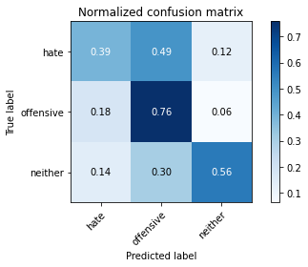

precision recall f1-score support

hate 0.12 0.39 0.18 41

offensive 0.23 0.76 0.36 95

neither 0.97 0.56 0.71 714

accuracy 0.57 850

macro avg 0.44 0.57 0.42 850

weighted avg 0.85 0.57 0.64 850

average eval_loss: 1.2489687058814736, accuracy: 0.571764705882353

training 9 epoch...

9.404386758804321 seconds used......

9 training finished! average train loss: 0.14233374119632775

total clf loss: 4.865626193583012 total adv loss: 0.129194228346023

evaluating...

Confusion matrix, without normalization

[[ 12 22 7]

[ 10 76 9]

[ 60 223 431]]

Normalized confusion matrix

[[0.29268293 0.53658537 0.17073171]

[0.10526316 0.8 0.09473684]

[0.08403361 0.31232493 0.60364146]]

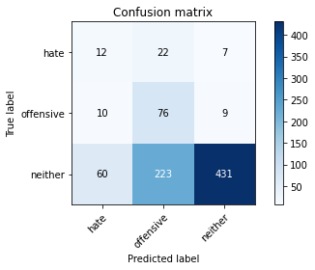

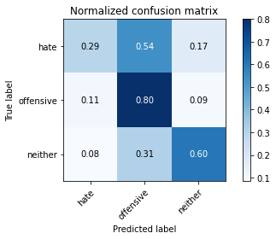

precision recall f1-score support

hate 0.15 0.29 0.20 41

offensive 0.24 0.80 0.37 95

neither 0.96 0.60 0.74 714

accuracy 0.61 850

macro avg 0.45 0.57 0.43 850

weighted avg 0.84 0.61 0.67 850

average eval_loss: 1.2238209175682344, accuracy: 0.6105882352941177

training 10 epoch...

9.299676895141602 seconds used......

10 training finished! average train loss: 0.09030877710837457

total clf loss: 3.1541149262338877 total adv loss: 0.04850052397887339

evaluating...

Confusion matrix, without normalization

[[ 18 17 6]

[ 15 72 8]

[ 97 188 429]]

Normalized confusion matrix

[[0.43902439 0.41463415 0.14634146]

[0.15789474 0.75789474 0.08421053]

[0.13585434 0.26330532 0.60084034]]

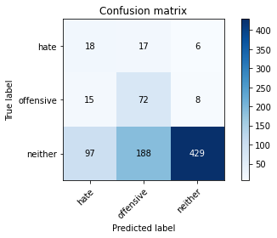

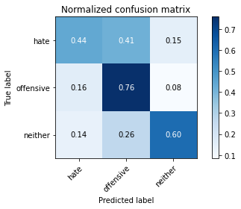

precision recall f1-score support

hate 0.14 0.44 0.21 41

offensive 0.26 0.76 0.39 95

neither 0.97 0.60 0.74 714

accuracy 0.61 850

macro avg 0.46 0.60 0.45 850

weighted avg 0.85 0.61 0.68 850

average eval_loss: 1.2357475077083637, accuracy: 0.6105882352941177

training 11 epoch...

9.347357749938965 seconds used......

11 training finished! average train loss: 0.06059238440098448

total clf loss: 2.1505668845493346 total adv loss: 0.015379480017145397

evaluating...

Confusion matrix, without normalization

[[ 19 17 5]

[ 15 74 6]

[116 200 398]]

Normalized confusion matrix

[[0.46341463 0.41463415 0.12195122]

[0.15789474 0.77894737 0.06315789]

[0.16246499 0.28011204 0.55742297]]

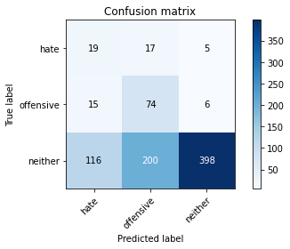

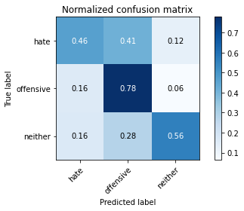

precision recall f1-score support

hate 0.13 0.46 0.20 41

offensive 0.25 0.78 0.38 95

neither 0.97 0.56 0.71 714

accuracy 0.58 850

macro avg 0.45 0.60 0.43 850

weighted avg 0.85 0.58 0.65 850

average eval_loss: 1.4315832806101372, accuracy: 0.5776470588235294

training 12 epoch...

9.411543607711792 seconds used......

12 training finished! average train loss: 0.03847372681937284

total clf loss: 1.3691526968032122 total adv loss: 0.007950738930048828

evaluating...

Confusion matrix, without normalization

[[ 17 17 7]

[ 14 71 10]

[ 97 188 429]]

Normalized confusion matrix

[[0.41463415 0.41463415 0.17073171]

[0.14736842 0.74736842 0.10526316]

[0.13585434 0.26330532 0.60084034]]

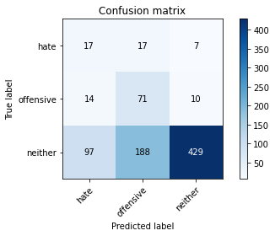

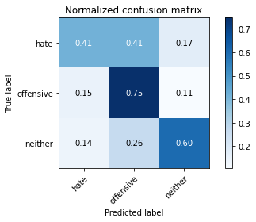

precision recall f1-score support

hate 0.13 0.41 0.20 41

offensive 0.26 0.75 0.38 95

neither 0.96 0.60 0.74 714

accuracy 0.61 850

macro avg 0.45 0.59 0.44 850

weighted avg 0.84 0.61 0.67 850

average eval_loss: 1.3710833298432272, accuracy: 0.6082352941176471

training 13 epoch...

9.29341173171997 seconds used......

13 training finished! average train loss: 0.024402434213293925

total clf loss: 0.8726850408129394 total adv loss: 0.0029012996656092582

evaluating...

Confusion matrix, without normalization

[[ 16 17 8]

[ 14 71 10]

[ 86 187 441]]

Normalized confusion matrix

[[0.3902439 0.41463415 0.19512195]

[0.14736842 0.74736842 0.10526316]

[0.12044818 0.26190476 0.61764706]]

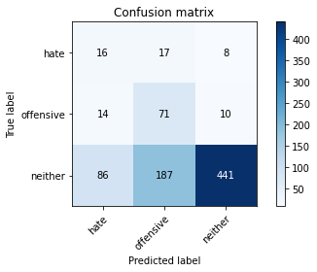

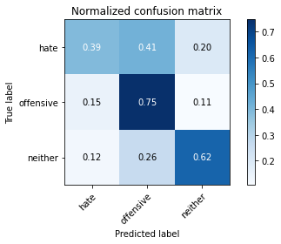

precision recall f1-score support

hate 0.14 0.39 0.20 41

offensive 0.26 0.75 0.38 95

neither 0.96 0.62 0.75 714

accuracy 0.62 850

macro avg 0.45 0.59 0.45 850

weighted avg 0.84 0.62 0.68 850

average eval_loss: 1.4011511239981236, accuracy: 0.6211764705882353

training 14 epoch...

9.327098846435547 seconds used......

14 training finished! average train loss: 0.017886898629108652

total clf loss: 0.629779334878549 total adv loss: 0.00707450991103542

evaluating...

Confusion matrix, without normalization

[[ 20 16 5]

[ 15 71 9]

[120 193 401]]

Normalized confusion matrix

[[0.48780488 0.3902439 0.12195122]

[0.15789474 0.74736842 0.09473684]

[0.16806723 0.27030812 0.56162465]]

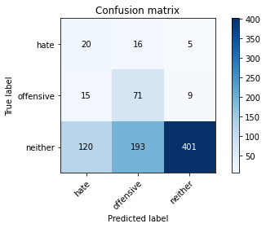

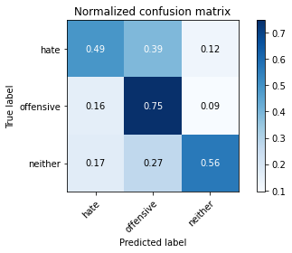

precision recall f1-score support

hate 0.13 0.49 0.20 41

offensive 0.25 0.75 0.38 95

neither 0.97 0.56 0.71 714

accuracy 0.58 850

macro avg 0.45 0.60 0.43 850

weighted avg 0.85 0.58 0.65 850

average eval_loss: 1.659791337196217, accuracy: 0.5788235294117647

training 15 epoch...

9.428606033325195 seconds used......

15 training finished! average train loss: 0.011532122683193948

total clf loss: 0.4086107178591192 total adv loss: 0.003272849593486171

evaluating...

Confusion matrix, without normalization

[[ 17 16 8]

[ 16 69 10]

[105 173 436]]

Normalized confusion matrix

[[0.41463415 0.3902439 0.19512195]

[0.16842105 0.72631579 0.10526316]

[0.14705882 0.24229692 0.61064426]]

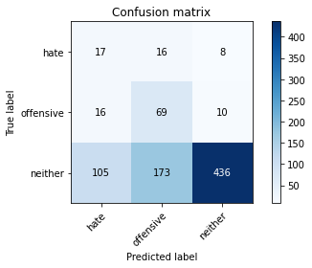

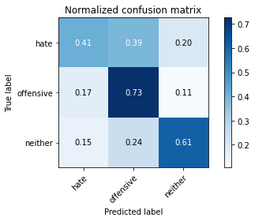

precision recall f1-score support

hate 0.12 0.41 0.19 41

offensive 0.27 0.73 0.39 95

neither 0.96 0.61 0.75 714

accuracy 0.61 850

macro avg 0.45 0.58 0.44 850

weighted avg 0.84 0.61 0.68 850

average eval_loss: 1.4835589391417627, accuracy: 0.6141176470588235

training 16 epoch...

9.290176153182983 seconds used......

16 training finished! average train loss: 0.009621474801355766

total clf loss: 0.3434054213576019 total adv loss: 0.0014838355286883598

evaluating...

Confusion matrix, without normalization

[[ 18 16 7]

[ 14 71 10]

[106 183 425]]

Normalized confusion matrix

[[0.43902439 0.3902439 0.17073171]

[0.14736842 0.74736842 0.10526316]

[0.14845938 0.25630252 0.5952381 ]]

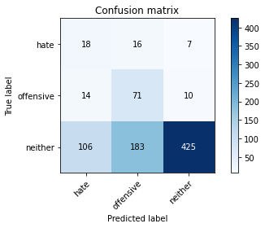

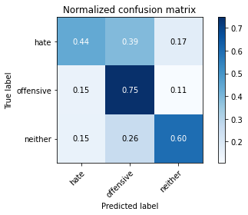

precision recall f1-score support

hate 0.13 0.44 0.20 41

offensive 0.26 0.75 0.39 95

neither 0.96 0.60 0.74 714

accuracy 0.60 850

macro avg 0.45 0.59 0.44 850

weighted avg 0.84 0.60 0.67 850

average eval_loss: 1.601892212773998, accuracy: 0.6047058823529412

training 17 epoch...

9.419872045516968 seconds used......

17 training finished! average train loss: 0.007708823360088799

total clf loss: 0.27326351148076355 total adv loss: 0.0021270645794970733

evaluating...

Confusion matrix, without normalization

[[ 17 16 8]

[ 12 69 14]

[ 83 182 449]]

Normalized confusion matrix

[[0.41463415 0.3902439 0.19512195]

[0.12631579 0.72631579 0.14736842]

[0.1162465 0.25490196 0.62885154]]

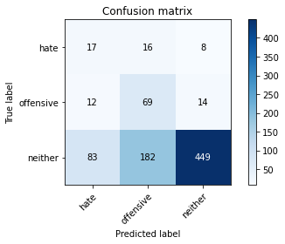

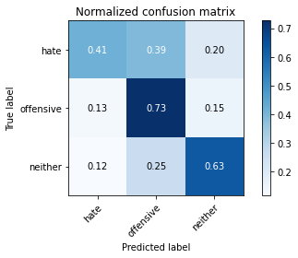

precision recall f1-score support

hate 0.15 0.41 0.22 41

offensive 0.26 0.73 0.38 95

neither 0.95 0.63 0.76 714

accuracy 0.63 850

macro avg 0.45 0.59 0.45 850

weighted avg 0.84 0.63 0.69 850

average eval_loss: 1.5569978588542273, accuracy: 0.6294117647058823

training 18 epoch...

9.282437562942505 seconds used......

18 training finished! average train loss: 0.006000158687432607

total clf loss: 0.21128042554482818 total adv loss: 0.002362643570450018

evaluating...

Confusion matrix, without normalization

[[ 17 16 8]

[ 16 66 13]

[100 174 440]]

Normalized confusion matrix

[[0.41463415 0.3902439 0.19512195]

[0.16842105 0.69473684 0.13684211]

[0.14005602 0.24369748 0.6162465 ]]

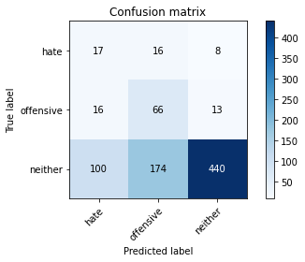

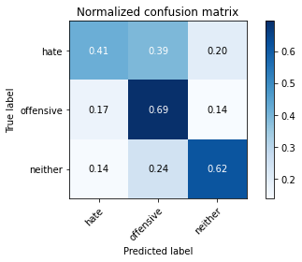

precision recall f1-score support

hate 0.13 0.41 0.20 41

offensive 0.26 0.69 0.38 95

neither 0.95 0.62 0.75 714

accuracy 0.62 850

macro avg 0.45 0.58 0.44 850

weighted avg 0.84 0.62 0.68 850

average eval_loss: 1.584807913717922, accuracy: 0.6152941176470588

training 19 epoch...

9.409488677978516 seconds used......

19 training finished! average train loss: 0.07898483971237308

total clf loss: 1.3713570451363921 total adv loss: 0.7360486020970711

evaluating...

Confusion matrix, without normalization

[[ 18 12 11]

[ 16 48 31]

[ 70 122 522]]

Normalized confusion matrix

[[0.43902439 0.29268293 0.26829268]

[0.16842105 0.50526316 0.32631579]

[0.09803922 0.17086835 0.73109244]]

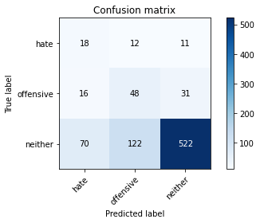

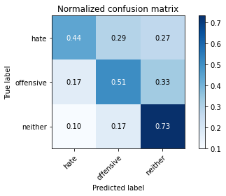

precision recall f1-score support

hate 0.17 0.44 0.25 41

offensive 0.26 0.51 0.35 95

neither 0.93 0.73 0.82 714

accuracy 0.69 850

macro avg 0.45 0.56 0.47 850

weighted avg 0.82 0.69 0.74 850

average eval_loss: 1.0513787840731268, accuracy: 0.691764705882353

training 20 epoch...

9.319159746170044 seconds used......

20 training finished! average train loss: 0.16533140037467497

total clf loss: 1.805084030609578 total adv loss: 2.0734232006816455

evaluating...

Confusion matrix, without normalization

[[ 17 20 4]

[ 16 70 9]

[125 209 380]]

Normalized confusion matrix

[[0.41463415 0.48780488 0.09756098]

[0.16842105 0.73684211 0.09473684]

[0.17507003 0.29271709 0.53221289]]

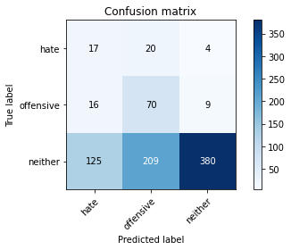

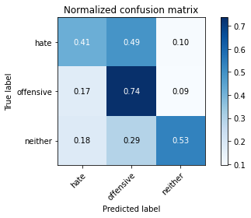

precision recall f1-score support

hate 0.11 0.41 0.17 41

offensive 0.23 0.74 0.36 95

neither 0.97 0.53 0.69 714

accuracy 0.55 850

macro avg 0.44 0.56 0.40 850

weighted avg 0.84 0.55 0.62 850

average eval_loss: 1.641313593748004, accuracy: 0.5494117647058824

2 run......

training 1 epoch...

9.358295679092407 seconds used......

1 training finished! average train loss: 2.485745151837667

total clf loss: 39.27557200193405 total adv loss: 25.10562700033188

evaluating...

Confusion matrix, without normalization

[[ 0 33 8]

[ 0 50 45]

[ 0 313 401]]

Normalized confusion matrix

[[0. 0.80487805 0.19512195]

[0. 0.52631579 0.47368421]

[0. 0.43837535 0.56162465]]

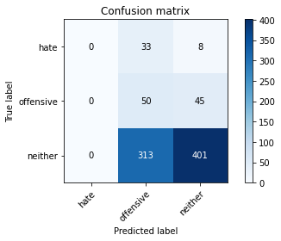

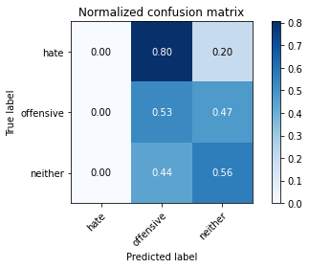

/opt/conda/lib/python3.7/site-packages/sklearn/metrics/_classification.py:1245: UndefinedMetricWarning: Precision and F-score are ill-defined and being set to 0.0 in labels with no predicted samples. Use `zero_division` parameter to control this behavior.

_warn_prf(average, modifier, msg_start, len(result))

/opt/conda/lib/python3.7/site-packages/sklearn/metrics/_classification.py:1245: UndefinedMetricWarning: Precision and F-score are ill-defined and being set to 0.0 in labels with no predicted samples. Use `zero_division` parameter to control this behavior.

_warn_prf(average, modifier, msg_start, len(result))

/opt/conda/lib/python3.7/site-packages/sklearn/metrics/_classification.py:1245: UndefinedMetricWarning: Precision and F-score are ill-defined and being set to 0.0 in labels with no predicted samples. Use `zero_division` parameter to control this behavior.

_warn_prf(average, modifier, msg_start, len(result))

precision recall f1-score support

hate 0.00 0.00 0.00 41

offensive 0.13 0.53 0.20 95

neither 0.88 0.56 0.69 714

accuracy 0.53 850

macro avg 0.34 0.36 0.30 850

weighted avg 0.76 0.53 0.60 850

average eval_loss: 0.9167605472165484, accuracy: 0.5305882352941177

training 2 epoch...

9.387627601623535 seconds used......

2 training finished! average train loss: 2.130452358060413

total clf loss: 34.05478525161743 total adv loss: 21.320749938488007

evaluating...

Confusion matrix, without normalization

[[ 0 36 5]

[ 0 82 13]

[ 0 327 387]]

Normalized confusion matrix

[[0. 0.87804878 0.12195122]

[0. 0.86315789 0.13684211]

[0. 0.45798319 0.54201681]]

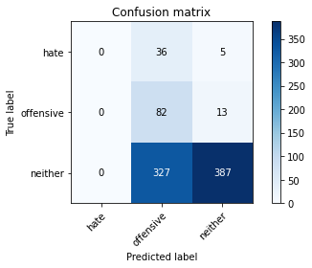

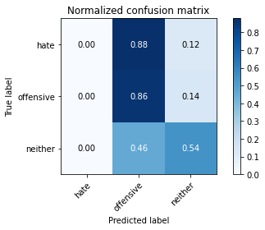

/opt/conda/lib/python3.7/site-packages/sklearn/metrics/_classification.py:1245: UndefinedMetricWarning: Precision and F-score are ill-defined and being set to 0.0 in labels with no predicted samples. Use `zero_division` parameter to control this behavior.

_warn_prf(average, modifier, msg_start, len(result))

/opt/conda/lib/python3.7/site-packages/sklearn/metrics/_classification.py:1245: UndefinedMetricWarning: Precision and F-score are ill-defined and being set to 0.0 in labels with no predicted samples. Use `zero_division` parameter to control this behavior.

_warn_prf(average, modifier, msg_start, len(result))

/opt/conda/lib/python3.7/site-packages/sklearn/metrics/_classification.py:1245: UndefinedMetricWarning: Precision and F-score are ill-defined and being set to 0.0 in labels with no predicted samples. Use `zero_division` parameter to control this behavior.

_warn_prf(average, modifier, msg_start, len(result))

precision recall f1-score support

hate 0.00 0.00 0.00 41

offensive 0.18 0.86 0.30 95

neither 0.96 0.54 0.69 714

accuracy 0.55 850

macro avg 0.38 0.47 0.33 850

weighted avg 0.82 0.55 0.61 850

average eval_loss: 0.8931460137977156, accuracy: 0.5517647058823529

training 3 epoch...

9.289521932601929 seconds used......

3 training finished! average train loss: 1.709860881169637

total clf loss: 28.185437500476837 total adv loss: 16.68477725982666

evaluating...

Confusion matrix, without normalization

[[ 1 20 20]

[ 0 55 40]

[ 5 133 576]]

Normalized confusion matrix

[[0.02439024 0.48780488 0.48780488]

[0. 0.57894737 0.42105263]

[0.0070028 0.18627451 0.80672269]]

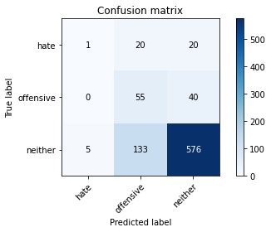

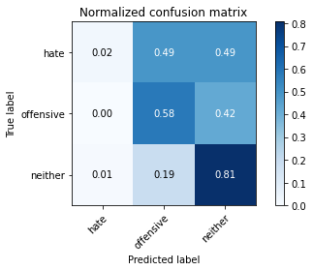

precision recall f1-score support

hate 0.17 0.02 0.04 41

offensive 0.26 0.58 0.36 95

neither 0.91 0.81 0.85 714

accuracy 0.74 850

macro avg 0.45 0.47 0.42 850

weighted avg 0.80 0.74 0.76 850

average eval_loss: 0.682349892203198, accuracy: 0.7435294117647059

training 4 epoch...

9.349756479263306 seconds used......

4 training finished! average train loss: 1.2499096906847424

total clf loss: 21.999720871448517 total adv loss: 11.498514145612717

evaluating...

Confusion matrix, without normalization

[[ 6 19 16]

[ 9 62 24]

[ 46 184 484]]

Normalized confusion matrix

[[0.14634146 0.46341463 0.3902439 ]

[0.09473684 0.65263158 0.25263158]

[0.06442577 0.25770308 0.67787115]]

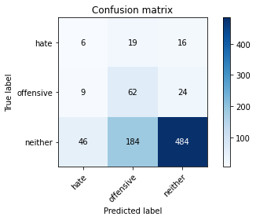

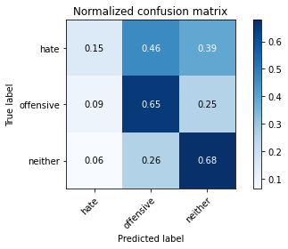

precision recall f1-score support

hate 0.10 0.15 0.12 41

offensive 0.23 0.65 0.34 95

neither 0.92 0.68 0.78 714

accuracy 0.65 850

macro avg 0.42 0.49 0.41 850

weighted avg 0.81 0.65 0.70 850

average eval_loss: 0.8334258561737315, accuracy: 0.6494117647058824

training 5 epoch...

9.328504085540771 seconds used......

5 training finished! average train loss: 0.840067446231842

total clf loss: 16.05634957551956 total adv loss: 7.093039404600859

evaluating...

Confusion matrix, without normalization

[[ 11 12 18]

[ 8 38 49]

[ 60 84 570]]

Normalized confusion matrix

[[0.26829268 0.29268293 0.43902439]

[0.08421053 0.4 0.51578947]

[0.08403361 0.11764706 0.79831933]]

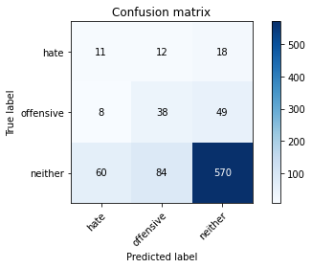

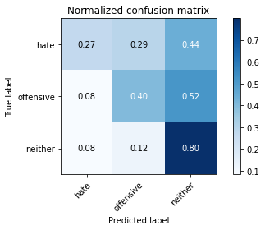

precision recall f1-score support

hate 0.14 0.27 0.18 41

offensive 0.28 0.40 0.33 95

neither 0.89 0.80 0.84 714

accuracy 0.73 850

macro avg 0.44 0.49 0.45 850

weighted avg 0.79 0.73 0.75 850

average eval_loss: 0.6905127067205518, accuracy: 0.7282352941176471

training 6 epoch...

9.263400793075562 seconds used......

6 training finished! average train loss: 0.41477422871523434

total clf loss: 11.17467476427555 total adv loss: 1.8785987384617329

evaluating...

Confusion matrix, without normalization

[[ 13 19 9]

[ 15 70 10]

[113 199 402]]

Normalized confusion matrix

[[0.31707317 0.46341463 0.2195122 ]

[0.15789474 0.73684211 0.10526316]

[0.15826331 0.27871148 0.56302521]]

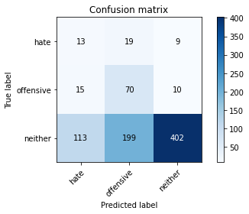

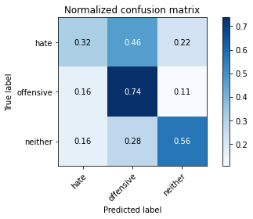

precision recall f1-score support

hate 0.09 0.32 0.14 41

offensive 0.24 0.74 0.37 95

neither 0.95 0.56 0.71 714

accuracy 0.57 850

macro avg 0.43 0.54 0.41 850

weighted avg 0.83 0.57 0.64 850

average eval_loss: 1.1233109512994455, accuracy: 0.5705882352941176

training 7 epoch...

9.404574155807495 seconds used......

7 training finished! average train loss: 0.21907684889932474

total clf loss: 7.39947260171175 total adv loss: 0.24364700380829163

evaluating...

Confusion matrix, without normalization

[[ 12 21 8]

[ 11 71 13]

[ 84 204 426]]

Normalized confusion matrix

[[0.29268293 0.51219512 0.19512195]

[0.11578947 0.74736842 0.13684211]

[0.11764706 0.28571429 0.59663866]]

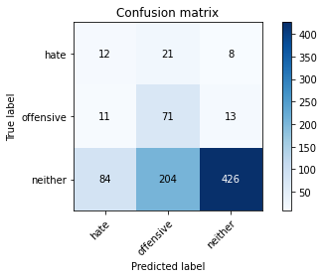

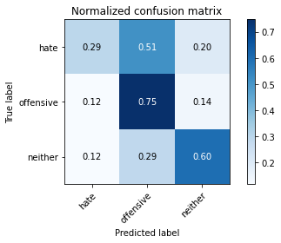

precision recall f1-score support

hate 0.11 0.29 0.16 41

offensive 0.24 0.75 0.36 95

neither 0.95 0.60 0.73 714

accuracy 0.60 850

macro avg 0.44 0.55 0.42 850

weighted avg 0.83 0.60 0.66 850

average eval_loss: 1.171965844755949, accuracy: 0.5988235294117648

training 8 epoch...

9.3034029006958 seconds used......

8 training finished! average train loss: 0.15060416014037198

total clf loss: 5.348436038941145 total adv loss: 0.036656866534030996

evaluating...

Confusion matrix, without normalization

[[ 15 17 9]

[ 11 69 15]

[ 88 191 435]]

Normalized confusion matrix

[[0.36585366 0.41463415 0.2195122 ]

[0.11578947 0.72631579 0.15789474]

[0.1232493 0.267507 0.6092437 ]]

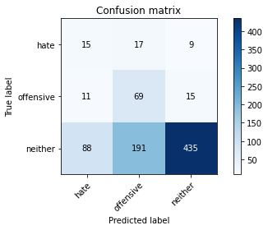

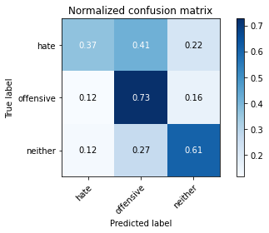

precision recall f1-score support

hate 0.13 0.37 0.19 41

offensive 0.25 0.73 0.37 95

neither 0.95 0.61 0.74 714

accuracy 0.61 850

macro avg 0.44 0.57 0.44 850

weighted avg 0.83 0.61 0.67 850

average eval_loss: 1.1636903354421604, accuracy: 0.6105882352941177

training 9 epoch...

9.391606330871582 seconds used......

9 training finished! average train loss: 0.10859159018016523

total clf loss: 3.7995332702994347 total adv loss: 0.05488196357691777

evaluating...

Confusion matrix, without normalization

[[ 14 12 15]

[ 17 53 25]

[ 92 131 491]]

Normalized confusion matrix

[[0.34146341 0.29268293 0.36585366]

[0.17894737 0.55789474 0.26315789]

[0.12885154 0.18347339 0.68767507]]

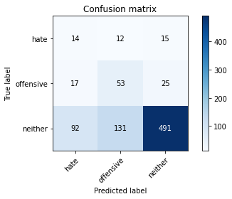

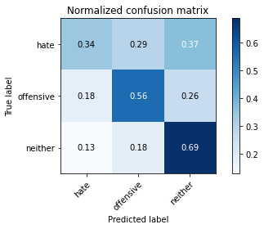

precision recall f1-score support

hate 0.11 0.34 0.17 41

offensive 0.27 0.56 0.36 95

neither 0.92 0.69 0.79 714

accuracy 0.66 850

macro avg 0.44 0.53 0.44 850

weighted avg 0.81 0.66 0.71 850

average eval_loss: 1.0446816978239737, accuracy: 0.6564705882352941

training 10 epoch...

9.306415319442749 seconds used......

10 training finished! average train loss: 0.07096190398765935

total clf loss: 2.5454928278923035 total adv loss: 0.004567861882833313

evaluating...

Confusion matrix, without normalization

[[ 15 15 11]

[ 13 65 17]

[ 94 165 455]]

Normalized confusion matrix

[[0.36585366 0.36585366 0.26829268]

[0.13684211 0.68421053 0.17894737]

[0.13165266 0.23109244 0.6372549 ]]

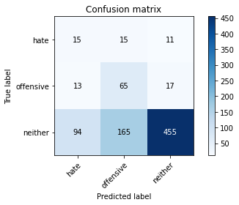

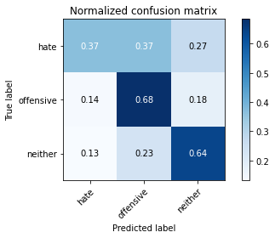

precision recall f1-score support

hate 0.12 0.37 0.18 41

offensive 0.27 0.68 0.38 95

neither 0.94 0.64 0.76 714

accuracy 0.63 850

macro avg 0.44 0.56 0.44 850

weighted avg 0.83 0.63 0.69 850

average eval_loss: 1.3026606980278048, accuracy: 0.6294117647058823

training 11 epoch...

9.260894060134888 seconds used......

11 training finished! average train loss: 0.04563345907566448

total clf loss: 1.626880501396954 total adv loss: 0.007962013390169886

evaluating...

Confusion matrix, without normalization

[[ 18 15 8]

[ 15 64 16]

[112 169 433]]

Normalized confusion matrix

[[0.43902439 0.36585366 0.19512195]

[0.15789474 0.67368421 0.16842105]

[0.15686275 0.23669468 0.60644258]]

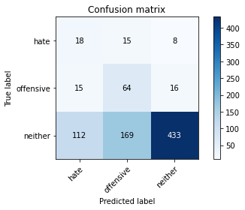

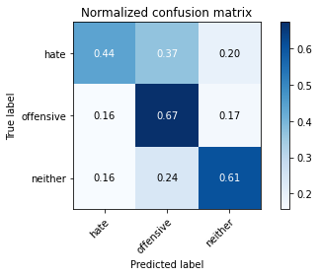

precision recall f1-score support

hate 0.12 0.44 0.19 41

offensive 0.26 0.67 0.37 95

neither 0.95 0.61 0.74 714

accuracy 0.61 850

macro avg 0.44 0.57 0.44 850

weighted avg 0.83 0.61 0.67 850

average eval_loss: 1.4804575214985498, accuracy: 0.6058823529411764

training 12 epoch...

9.373926401138306 seconds used......

12 training finished! average train loss: 0.03414335588200225

total clf loss: 1.182831074576825 total adv loss: 0.023164868559831575

evaluating...

Confusion matrix, without normalization

[[ 9 19 13]

[ 10 64 21]

[ 68 178 468]]

Normalized confusion matrix

[[0.2195122 0.46341463 0.31707317]

[0.10526316 0.67368421 0.22105263]

[0.0952381 0.24929972 0.65546218]]

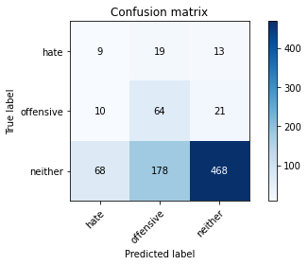

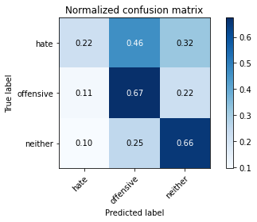

precision recall f1-score support

hate 0.10 0.22 0.14 41

offensive 0.25 0.67 0.36 95

neither 0.93 0.66 0.77 714

accuracy 0.64 850

macro avg 0.43 0.52 0.42 850

weighted avg 0.82 0.64 0.69 850

average eval_loss: 1.4240911899805935, accuracy: 0.6364705882352941

training 13 epoch...

9.32174277305603 seconds used......

13 training finished! average train loss: 0.06895211615806653

total clf loss: 1.3870812612585723 total adv loss: 0.5475974564828903

evaluating...

Confusion matrix, without normalization

[[ 15 17 9]

[ 15 66 14]

[110 204 400]]

Normalized confusion matrix

[[0.36585366 0.41463415 0.2195122 ]

[0.15789474 0.69473684 0.14736842]

[0.15406162 0.28571429 0.56022409]]

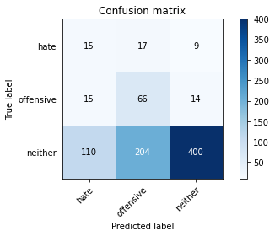

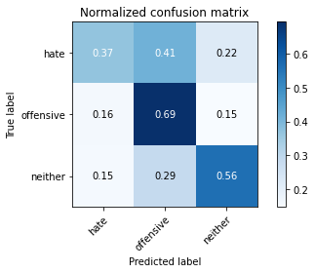

precision recall f1-score support

hate 0.11 0.37 0.17 41

offensive 0.23 0.69 0.35 95

neither 0.95 0.56 0.70 714

accuracy 0.57 850

macro avg 0.43 0.54 0.40 850

weighted avg 0.83 0.57 0.64 850

average eval_loss: 1.671199358046748, accuracy: 0.5658823529411765

training 14 epoch...

9.380925416946411 seconds used......

14 training finished! average train loss: 0.20844200825215214

total clf loss: 2.8027175911702216 total adv loss: 2.350597330409073

evaluating...

Confusion matrix, without normalization

[[ 3 20 18]

[ 3 64 28]

[ 13 166 535]]

Normalized confusion matrix

[[0.07317073 0.48780488 0.43902439]

[0.03157895 0.67368421 0.29473684]

[0.01820728 0.232493 0.74929972]]

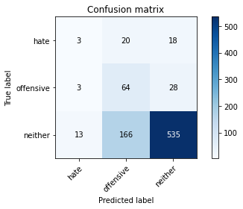

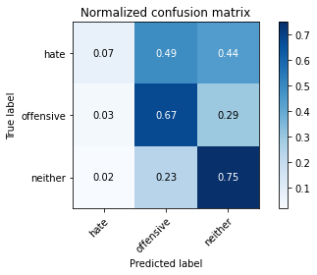

precision recall f1-score support

hate 0.16 0.07 0.10 41

offensive 0.26 0.67 0.37 95

neither 0.92 0.75 0.83 714

accuracy 0.71 850

macro avg 0.44 0.50 0.43 850

weighted avg 0.81 0.71 0.74 850

average eval_loss: 1.0491702221442274, accuracy: 0.7082352941176471

training 15 epoch...

9.306427955627441 seconds used......

15 training finished! average train loss: 0.07239262397504515

total clf loss: 1.8336120642488822 total adv loss: 0.3862611871882109

evaluating...

Confusion matrix, without normalization

[[ 18 13 10]

[ 14 61 20]

[ 96 127 491]]

Normalized confusion matrix

[[0.43902439 0.31707317 0.24390244]

[0.14736842 0.64210526 0.21052632]

[0.13445378 0.17787115 0.68767507]]

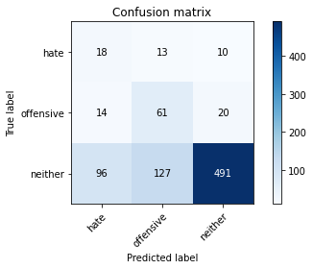

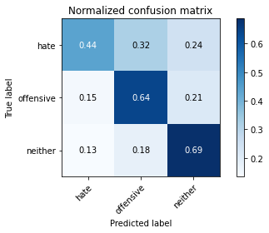

precision recall f1-score support

hate 0.14 0.44 0.21 41

offensive 0.30 0.64 0.41 95

neither 0.94 0.69 0.80 714

accuracy 0.67 850

macro avg 0.46 0.59 0.47 850

weighted avg 0.83 0.67 0.72 850

average eval_loss: 1.1246803396186509, accuracy: 0.6705882352941176

training 16 epoch...

9.262371301651001 seconds used......

16 training finished! average train loss: 0.022688040535690054

total clf loss: 0.703879642765969 total adv loss: 0.056444901769282296

evaluating...

Confusion matrix, without normalization

[[ 16 16 9]

[ 14 66 15]

[ 89 169 456]]

Normalized confusion matrix

[[0.3902439 0.3902439 0.2195122 ]

[0.14736842 0.69473684 0.15789474]

[0.12464986 0.23669468 0.63865546]]

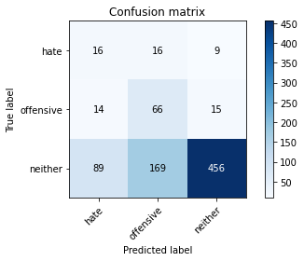

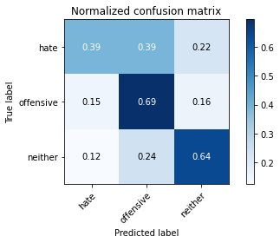

precision recall f1-score support

hate 0.13 0.39 0.20 41

offensive 0.26 0.69 0.38 95

neither 0.95 0.64 0.76 714

accuracy 0.63 850

macro avg 0.45 0.57 0.45 850

weighted avg 0.83 0.63 0.69 850

average eval_loss: 1.3921405621696004, accuracy: 0.6329411764705882

training 17 epoch...

9.381193399429321 seconds used......

17 training finished! average train loss: 0.013316579706345996

total clf loss: 0.45110987196676433 total adv loss: 0.014143496704491554

evaluating...

Confusion matrix, without normalization

[[ 18 13 10]

[ 15 63 17]

[ 99 143 472]]

Normalized confusion matrix

[[0.43902439 0.31707317 0.24390244]

[0.15789474 0.66315789 0.17894737]

[0.13865546 0.20028011 0.66106443]]

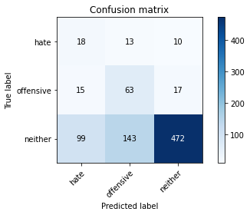

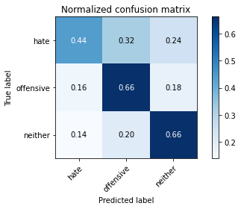

precision recall f1-score support

hate 0.14 0.44 0.21 41

offensive 0.29 0.66 0.40 95

neither 0.95 0.66 0.78 714

accuracy 0.65 850

macro avg 0.46 0.59 0.46 850

weighted avg 0.83 0.65 0.71 850

average eval_loss: 1.3737808617568292, accuracy: 0.6505882352941177

training 18 epoch...

9.306763410568237 seconds used......

18 training finished! average train loss: 0.010849880298741886

total clf loss: 0.3646505805081688 total adv loss: 0.012972555377885442

evaluating...

Confusion matrix, without normalization

[[ 17 15 9]

[ 15 64 16]

[ 95 152 467]]

Normalized confusion matrix

[[0.41463415 0.36585366 0.2195122 ]

[0.15789474 0.67368421 0.16842105]

[0.13305322 0.21288515 0.65406162]]

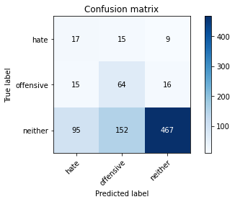

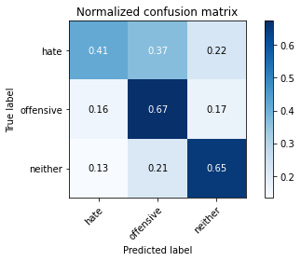

precision recall f1-score support

hate 0.13 0.41 0.20 41

offensive 0.28 0.67 0.39 95

neither 0.95 0.65 0.77 714

accuracy 0.64 850

macro avg 0.45 0.58 0.46 850

weighted avg 0.83 0.64 0.70 850

average eval_loss: 1.4461356542441388, accuracy: 0.6447058823529411

training 19 epoch...

9.38988971710205 seconds used......

19 training finished! average train loss: 0.006637272935929812

total clf loss: 0.23553626262582839 total adv loss: 0.001702781278254406

evaluating...

Confusion matrix, without normalization

[[ 14 17 10]

[ 14 64 17]

[ 83 165 466]]

Normalized confusion matrix

[[0.34146341 0.41463415 0.24390244]

[0.14736842 0.67368421 0.17894737]

[0.1162465 0.23109244 0.65266106]]

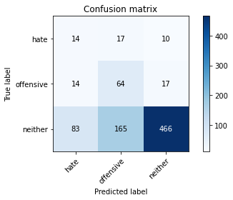

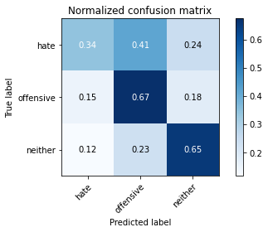

precision recall f1-score support

hate 0.13 0.34 0.18 41

offensive 0.26 0.67 0.38 95

neither 0.95 0.65 0.77 714

accuracy 0.64 850

macro avg 0.44 0.56 0.44 850

weighted avg 0.83 0.64 0.70 850

average eval_loss: 1.4739776941796028, accuracy: 0.64

training 20 epoch...

9.30736231803894 seconds used......

20 training finished! average train loss: 0.006299716957275652

total clf loss: 0.21797661925666034 total adv loss: 0.004406595555337844

evaluating...

Confusion matrix, without normalization

[[ 16 14 11]

[ 14 64 17]

[ 92 149 473]]

Normalized confusion matrix

[[0.3902439 0.34146341 0.26829268]

[0.14736842 0.67368421 0.17894737]

[0.12885154 0.20868347 0.66246499]]

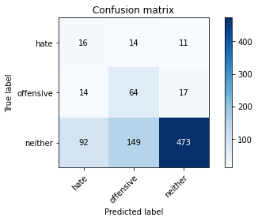

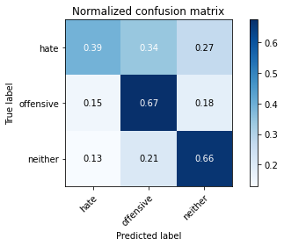

precision recall f1-score support

hate 0.13 0.39 0.20 41

offensive 0.28 0.67 0.40 95

neither 0.94 0.66 0.78 714

accuracy 0.65 850

macro avg 0.45 0.58 0.46 850

weighted avg 0.83 0.65 0.71 850

average eval_loss: 1.4601131782780379, accuracy: 0.6505882352941177

3 run......

training 1 epoch...

9.36719036102295 seconds used......

1 training finished! average train loss: 2.4276810189088187

total clf loss: 39.62968301773071 total adv loss: 23.883416712284088

evaluating...

Confusion matrix, without normalization

[[ 0 32 9]

[ 0 60 35]

[ 0 281 433]]

Normalized confusion matrix

[[0. 0.7804878 0.2195122 ]

[0. 0.63157895 0.36842105]

[0. 0.39355742 0.60644258]]

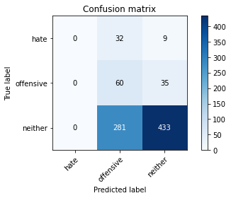

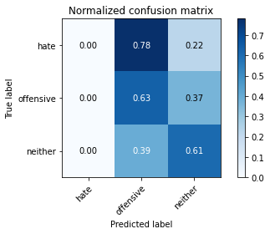

/opt/conda/lib/python3.7/site-packages/sklearn/metrics/_classification.py:1245: UndefinedMetricWarning: Precision and F-score are ill-defined and being set to 0.0 in labels with no predicted samples. Use `zero_division` parameter to control this behavior.

_warn_prf(average, modifier, msg_start, len(result))

/opt/conda/lib/python3.7/site-packages/sklearn/metrics/_classification.py:1245: UndefinedMetricWarning: Precision and F-score are ill-defined and being set to 0.0 in labels with no predicted samples. Use `zero_division` parameter to control this behavior.

_warn_prf(average, modifier, msg_start, len(result))

/opt/conda/lib/python3.7/site-packages/sklearn/metrics/_classification.py:1245: UndefinedMetricWarning: Precision and F-score are ill-defined and being set to 0.0 in labels with no predicted samples. Use `zero_division` parameter to control this behavior.

_warn_prf(average, modifier, msg_start, len(result))

precision recall f1-score support

hate 0.00 0.00 0.00 41

offensive 0.16 0.63 0.26 95

neither 0.91 0.61 0.73 714

accuracy 0.58 850

macro avg 0.36 0.41 0.33 850

weighted avg 0.78 0.58 0.64 850

average eval_loss: 0.8723959576251895, accuracy: 0.58

training 2 epoch...

9.286954641342163 seconds used......

2 training finished! average train loss: 2.0804418159855738

total clf loss: 34.44368249177933 total adv loss: 20.226111501455307

evaluating...

Confusion matrix, without normalization

[[ 0 23 18]

[ 0 43 52]

[ 0 169 545]]

Normalized confusion matrix

[[0. 0.56097561 0.43902439]

[0. 0.45263158 0.54736842]

[0. 0.23669468 0.76330532]]

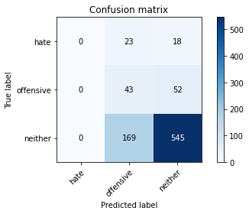

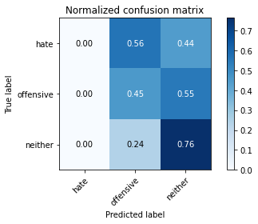

/opt/conda/lib/python3.7/site-packages/sklearn/metrics/_classification.py:1245: UndefinedMetricWarning: Precision and F-score are ill-defined and being set to 0.0 in labels with no predicted samples. Use `zero_division` parameter to control this behavior.

_warn_prf(average, modifier, msg_start, len(result))

/opt/conda/lib/python3.7/site-packages/sklearn/metrics/_classification.py:1245: UndefinedMetricWarning: Precision and F-score are ill-defined and being set to 0.0 in labels with no predicted samples. Use `zero_division` parameter to control this behavior.

_warn_prf(average, modifier, msg_start, len(result))

/opt/conda/lib/python3.7/site-packages/sklearn/metrics/_classification.py:1245: UndefinedMetricWarning: Precision and F-score are ill-defined and being set to 0.0 in labels with no predicted samples. Use `zero_division` parameter to control this behavior.

_warn_prf(average, modifier, msg_start, len(result))

precision recall f1-score support

hate 0.00 0.00 0.00 41

offensive 0.18 0.45 0.26 95

neither 0.89 0.76 0.82 714

accuracy 0.69 850

macro avg 0.36 0.41 0.36 850

weighted avg 0.76 0.69 0.72 850

average eval_loss: 0.7655526706299116, accuracy: 0.691764705882353

training 3 epoch...

9.285940408706665 seconds used......

3 training finished! average train loss: 1.6643780204984877

total clf loss: 29.35868936777115 total adv loss: 15.279459655284882

evaluating...

Confusion matrix, without normalization

[[ 0 31 10]

[ 0 72 23]

[ 0 279 435]]

Normalized confusion matrix

[[0. 0.75609756 0.24390244]

[0. 0.75789474 0.24210526]

[0. 0.3907563 0.6092437 ]]

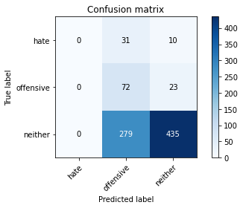

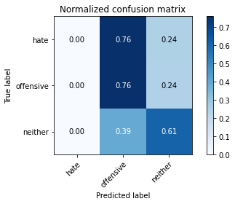

/opt/conda/lib/python3.7/site-packages/sklearn/metrics/_classification.py:1245: UndefinedMetricWarning: Precision and F-score are ill-defined and being set to 0.0 in labels with no predicted samples. Use `zero_division` parameter to control this behavior.

_warn_prf(average, modifier, msg_start, len(result))

/opt/conda/lib/python3.7/site-packages/sklearn/metrics/_classification.py:1245: UndefinedMetricWarning: Precision and F-score are ill-defined and being set to 0.0 in labels with no predicted samples. Use `zero_division` parameter to control this behavior.

_warn_prf(average, modifier, msg_start, len(result))

/opt/conda/lib/python3.7/site-packages/sklearn/metrics/_classification.py:1245: UndefinedMetricWarning: Precision and F-score are ill-defined and being set to 0.0 in labels with no predicted samples. Use `zero_division` parameter to control this behavior.

_warn_prf(average, modifier, msg_start, len(result))

precision recall f1-score support

hate 0.00 0.00 0.00 41

offensive 0.19 0.76 0.30 95

neither 0.93 0.61 0.74 714

accuracy 0.60 850

macro avg 0.37 0.46 0.35 850

weighted avg 0.80 0.60 0.65 850

average eval_loss: 0.8495489178701888, accuracy: 0.5964705882352941

training 4 epoch...

9.407601833343506 seconds used......

4 training finished! average train loss: 1.1452873829338286

total clf loss: 23.124001920223236 total adv loss: 9.053172241896391

evaluating...

Confusion matrix, without normalization

[[ 3 18 20]

[ 2 60 33]

[ 11 155 548]]

Normalized confusion matrix

[[0.07317073 0.43902439 0.48780488]

[0.02105263 0.63157895 0.34736842]

[0.01540616 0.21708683 0.767507 ]]

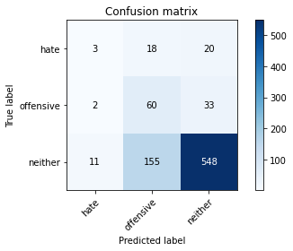

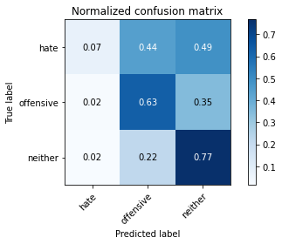

precision recall f1-score support

hate 0.19 0.07 0.11 41

offensive 0.26 0.63 0.37 95

neither 0.91 0.77 0.83 714

accuracy 0.72 850

macro avg 0.45 0.49 0.43 850

weighted avg 0.80 0.72 0.75 850

average eval_loss: 0.7247091570739136, accuracy: 0.7188235294117648

training 5 epoch...

9.300105094909668 seconds used......

5 training finished! average train loss: 0.6769362688064575

total clf loss: 16.857590079307556 total adv loss: 3.7560578705742955

evaluating...

Confusion matrix, without normalization

[[ 7 18 16]

[ 4 72 19]

[ 26 195 493]]

Normalized confusion matrix

[[0.17073171 0.43902439 0.3902439 ]

[0.04210526 0.75789474 0.2 ]

[0.03641457 0.27310924 0.69047619]]

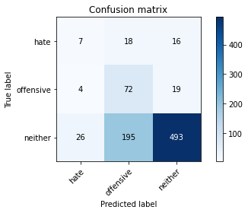

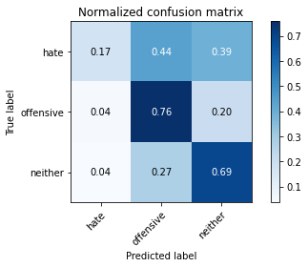

precision recall f1-score support

hate 0.19 0.17 0.18 41

offensive 0.25 0.76 0.38 95

neither 0.93 0.69 0.79 714

accuracy 0.67 850

macro avg 0.46 0.54 0.45 850

weighted avg 0.82 0.67 0.72 850

average eval_loss: 0.8037326694574467, accuracy: 0.6729411764705883

training 6 epoch...

9.396522521972656 seconds used......

6 training finished! average train loss: 0.40281931683421135

total clf loss: 12.256338357925415 total adv loss: 1.1225784709095024

evaluating...

Confusion matrix, without normalization

[[ 14 19 8]

[ 11 73 11]

[ 93 180 441]]

Normalized confusion matrix

[[0.34146341 0.46341463 0.19512195]

[0.11578947 0.76842105 0.11578947]

[0.1302521 0.25210084 0.61764706]]

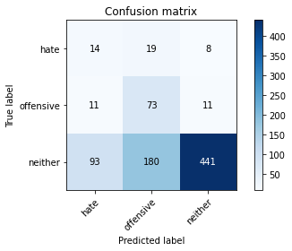

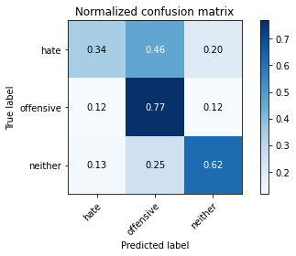

precision recall f1-score support

hate 0.12 0.34 0.18 41

offensive 0.27 0.77 0.40 95

neither 0.96 0.62 0.75 714

accuracy 0.62 850

macro avg 0.45 0.58 0.44 850

weighted avg 0.84 0.62 0.68 850

average eval_loss: 0.9510339437875637, accuracy: 0.6211764705882353

training 7 epoch...

9.316975593566895 seconds used......

7 training finished! average train loss: 0.2678518575719661

total clf loss: 9.144740670919418 total adv loss: 0.24896308180177584

evaluating...

Confusion matrix, without normalization

[[ 14 20 7]

[ 10 73 12]

[100 195 419]]

Normalized confusion matrix

[[0.34146341 0.48780488 0.17073171]

[0.10526316 0.76842105 0.12631579]

[0.14005602 0.27310924 0.58683473]]

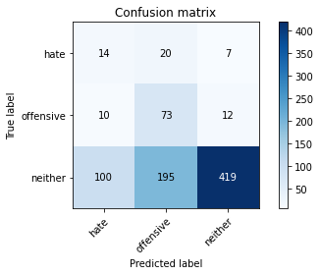

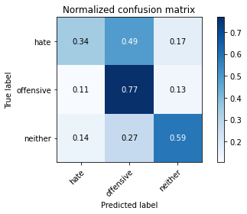

precision recall f1-score support

hate 0.11 0.34 0.17 41

offensive 0.25 0.77 0.38 95

neither 0.96 0.59 0.73 714

accuracy 0.60 850

macro avg 0.44 0.57 0.43 850

weighted avg 0.84 0.60 0.66 850

average eval_loss: 1.0779302316869415, accuracy: 0.5952941176470589

training 8 epoch...

9.270522117614746 seconds used......

8 training finished! average train loss: 0.20654687927001053

total clf loss: 6.728500723838806 total adv loss: 0.3535934852043283

evaluating...

Confusion matrix, without normalization

[[ 15 10 16]

[ 12 59 24]

[ 72 79 563]]

Normalized confusion matrix

[[0.36585366 0.24390244 0.3902439 ]

[0.12631579 0.62105263 0.25263158]

[0.10084034 0.11064426 0.78851541]]

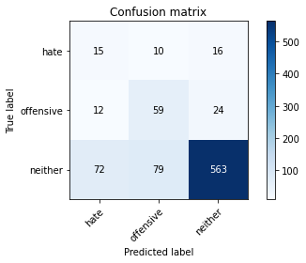

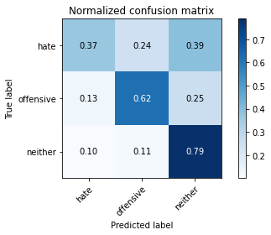

precision recall f1-score support

hate 0.15 0.37 0.21 41

offensive 0.40 0.62 0.49 95

neither 0.93 0.79 0.85 714

accuracy 0.75 850

macro avg 0.49 0.59 0.52 850

weighted avg 0.84 0.75 0.78 850

average eval_loss: 0.7162509700933168, accuracy: 0.7494117647058823

training 9 epoch...

9.407044410705566 seconds used......

9 training finished! average train loss: 0.19112835079431534

total clf loss: 6.236122101545334 total adv loss: 0.3222492608183529

evaluating...

Confusion matrix, without normalization

[[ 10 24 7]

[ 5 78 12]

[ 53 266 395]]

Normalized confusion matrix

[[0.24390244 0.58536585 0.17073171]

[0.05263158 0.82105263 0.12631579]

[0.07422969 0.37254902 0.55322129]]

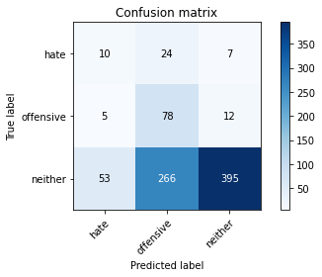

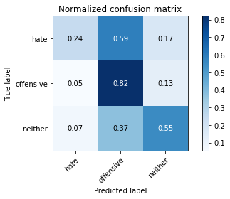

precision recall f1-score support

hate 0.15 0.24 0.18 41

offensive 0.21 0.82 0.34 95

neither 0.95 0.55 0.70 714

accuracy 0.57 850

macro avg 0.44 0.54 0.41 850

weighted avg 0.83 0.57 0.63 850

average eval_loss: 1.5204634994355053, accuracy: 0.5682352941176471

training 10 epoch...

9.311402797698975 seconds used......

10 training finished! average train loss: 0.19417233467619452

total clf loss: 5.192357642110437 total adv loss: 0.8989232349013037

evaluating...

Confusion matrix, without normalization

[[ 11 21 9]

[ 6 74 15]

[ 47 171 496]]

Normalized confusion matrix

[[0.26829268 0.51219512 0.2195122 ]

[0.06315789 0.77894737 0.15789474]

[0.06582633 0.2394958 0.69467787]]

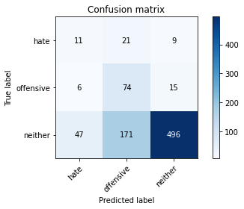

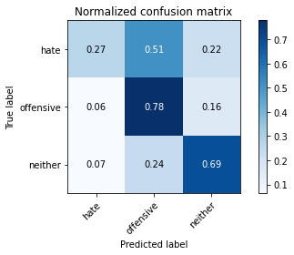

precision recall f1-score support

hate 0.17 0.27 0.21 41

offensive 0.28 0.78 0.41 95

neither 0.95 0.69 0.80 714

accuracy 0.68 850

macro avg 0.47 0.58 0.47 850

weighted avg 0.84 0.68 0.73 850

average eval_loss: 0.9473593553398237, accuracy: 0.6835294117647058

training 11 epoch...

9.369986772537231 seconds used......

11 training finished! average train loss: 0.097275720960978

total clf loss: 3.449247445911169 total adv loss: 0.026339252617617603

evaluating...

Confusion matrix, without normalization

[[ 11 21 9]

[ 7 73 15]

[ 74 148 492]]

Normalized confusion matrix

[[0.26829268 0.51219512 0.2195122 ]

[0.07368421 0.76842105 0.15789474]

[0.10364146 0.20728291 0.68907563]]

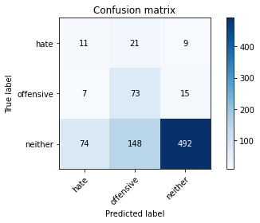

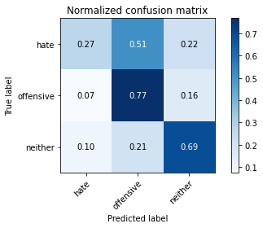

precision recall f1-score support

hate 0.12 0.27 0.17 41

offensive 0.30 0.77 0.43 95

neither 0.95 0.69 0.80 714

accuracy 0.68 850

macro avg 0.46 0.58 0.47 850

weighted avg 0.84 0.68 0.73 850

average eval_loss: 1.0136584793325774, accuracy: 0.6776470588235294

training 12 epoch...

9.316431999206543 seconds used......

12 training finished! average train loss: 0.07089324264476697

total clf loss: 2.4003332164138556 total adv loss: 0.0759117615316427

evaluating...

Confusion matrix, without normalization

[[ 12 20 9]

[ 12 70 13]

[109 148 457]]

Normalized confusion matrix

[[0.29268293 0.48780488 0.2195122 ]

[0.12631579 0.73684211 0.13684211]

[0.15266106 0.20728291 0.64005602]]

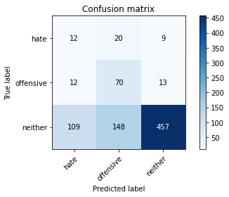

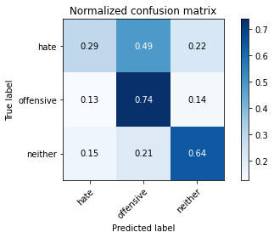

precision recall f1-score support

hate 0.09 0.29 0.14 41

offensive 0.29 0.74 0.42 95

neither 0.95 0.64 0.77 714

accuracy 0.63 850

macro avg 0.45 0.56 0.44 850

weighted avg 0.84 0.63 0.70 850

average eval_loss: 1.1616489684079276, accuracy: 0.6341176470588236

training 13 epoch...

9.262399673461914 seconds used......

13 training finished! average train loss: 0.050684990723513894

total clf loss: 1.8158588279038668 total adv loss: 0.004400422846629226

evaluating...

Confusion matrix, without normalization

[[ 12 20 9]

[ 9 71 15]

[ 87 155 472]]

Normalized confusion matrix

[[0.29268293 0.48780488 0.2195122 ]

[0.09473684 0.74736842 0.15789474]

[0.12184874 0.21708683 0.66106443]]

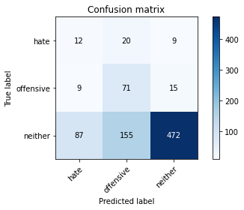

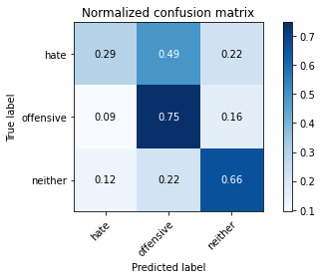

precision recall f1-score support

hate 0.11 0.29 0.16 41

offensive 0.29 0.75 0.42 95

neither 0.95 0.66 0.78 714

accuracy 0.65 850

macro avg 0.45 0.57 0.45 850

weighted avg 0.84 0.65 0.71 850

average eval_loss: 1.1835453909670197, accuracy: 0.6529411764705882

training 14 epoch...

9.400237083435059 seconds used......

14 training finished! average train loss: 0.03115062226748301

total clf loss: 1.114385197404772 total adv loss: 0.0035186023624191876

evaluating...

Confusion matrix, without normalization

[[ 13 19 9]

[ 9 71 15]

[ 80 167 467]]

Normalized confusion matrix

[[0.31707317 0.46341463 0.2195122 ]

[0.09473684 0.74736842 0.15789474]

[0.11204482 0.23389356 0.65406162]]

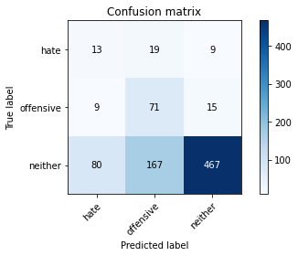

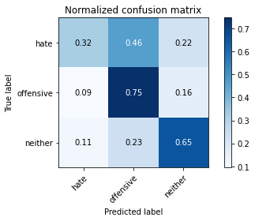

precision recall f1-score support

hate 0.13 0.32 0.18 41

offensive 0.28 0.75 0.40 95

neither 0.95 0.65 0.78 714

accuracy 0.65 850

macro avg 0.45 0.57 0.45 850

weighted avg 0.84 0.65 0.70 850

average eval_loss: 1.2650387450879397, accuracy: 0.648235294117647

training 15 epoch...

9.328930616378784 seconds used......

15 training finished! average train loss: 0.02156913636200544

total clf loss: 0.7682724739424884 total adv loss: 0.004108218870328528

evaluating...

Confusion matrix, without normalization

[[ 12 19 10]

[ 9 70 16]

[ 89 159 466]]

Normalized confusion matrix

[[0.29268293 0.46341463 0.24390244]

[0.09473684 0.73684211 0.16842105]

[0.12464986 0.22268908 0.65266106]]

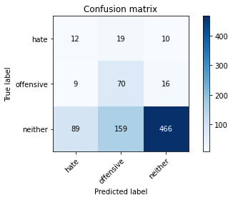

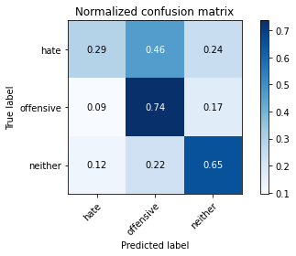

precision recall f1-score support

hate 0.11 0.29 0.16 41

offensive 0.28 0.74 0.41 95

neither 0.95 0.65 0.77 714

accuracy 0.64 850

macro avg 0.45 0.56 0.45 850

weighted avg 0.83 0.64 0.70 850

average eval_loss: 1.3129222372135276, accuracy: 0.6447058823529411

training 16 epoch...

9.40590786933899 seconds used......

16 training finished! average train loss: 0.021520017319643456

total clf loss: 0.6746103502810001 total adv loss: 0.05005513983945775

evaluating...

Confusion matrix, without normalization

[[ 14 21 6]

[ 10 79 6]

[103 217 394]]

Normalized confusion matrix

[[0.34146341 0.51219512 0.14634146]

[0.10526316 0.83157895 0.06315789]

[0.1442577 0.30392157 0.55182073]]

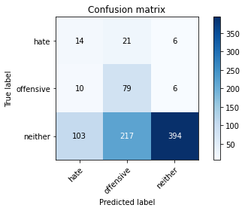

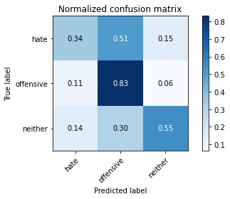

precision recall f1-score support

hate 0.11 0.34 0.17 41

offensive 0.25 0.83 0.38 95

neither 0.97 0.55 0.70 714

accuracy 0.57 850

macro avg 0.44 0.57 0.42 850

weighted avg 0.85 0.57 0.64 850

average eval_loss: 1.7892083381519241, accuracy: 0.5729411764705883

training 17 epoch...

9.303537368774414 seconds used......

17 training finished! average train loss: 0.024584441070651844

total clf loss: 0.5918913120403886 total adv loss: 0.14657429038288683

evaluating...

Confusion matrix, without normalization

[[ 19 9 13]

[ 11 67 17]

[104 94 516]]

Normalized confusion matrix

[[0.46341463 0.2195122 0.31707317]

[0.11578947 0.70526316 0.17894737]

[0.14565826 0.13165266 0.72268908]]

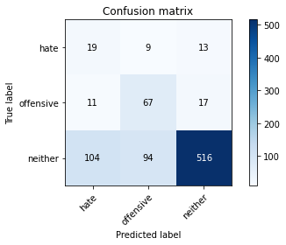

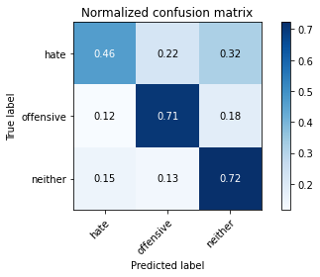

precision recall f1-score support

hate 0.14 0.46 0.22 41

offensive 0.39 0.71 0.51 95

neither 0.95 0.72 0.82 714

accuracy 0.71 850

macro avg 0.49 0.63 0.51 850

weighted avg 0.84 0.71 0.75 850

average eval_loss: 1.0391645657093547, accuracy: 0.7082352941176471

training 18 epoch...

9.321902990341187 seconds used......

18 training finished! average train loss: 0.041859770698162414

total clf loss: 0.726596315857023 total adv loss: 0.3901777152592558

evaluating...

Confusion matrix, without normalization

[[ 19 10 12]

[ 11 65 19]

[ 94 110 510]]

Normalized confusion matrix

[[0.46341463 0.24390244 0.29268293]

[0.11578947 0.68421053 0.2 ]

[0.13165266 0.15406162 0.71428571]]

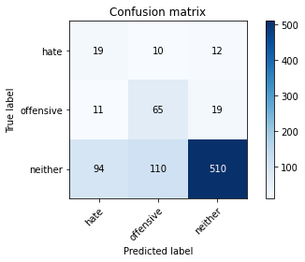

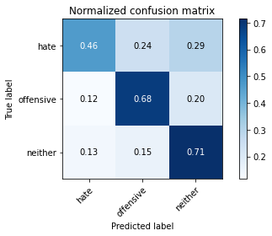

precision recall f1-score support

hate 0.15 0.46 0.23 41

offensive 0.35 0.68 0.46 95

neither 0.94 0.71 0.81 714

accuracy 0.70 850

macro avg 0.48 0.62 0.50 850

weighted avg 0.84 0.70 0.75 850

average eval_loss: 1.1108595331762592, accuracy: 0.6988235294117647

training 19 epoch...

9.33549165725708 seconds used......

19 training finished! average train loss: 0.17147979168092004

total clf loss: 1.7643445124849677 total adv loss: 2.2044639946720963

evaluating...

Confusion matrix, without normalization

[[ 11 19 11]

[ 5 71 19]

[ 60 155 499]]

Normalized confusion matrix

[[0.26829268 0.46341463 0.26829268]

[0.05263158 0.74736842 0.2 ]

[0.08403361 0.21708683 0.69887955]]

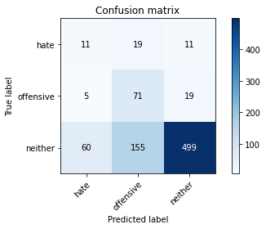

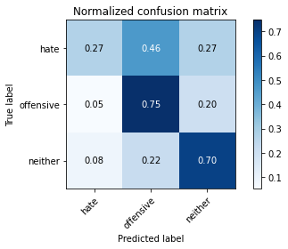

precision recall f1-score support

hate 0.14 0.27 0.19 41

offensive 0.29 0.75 0.42 95

neither 0.94 0.70 0.80 714

accuracy 0.68 850

macro avg 0.46 0.57 0.47 850

weighted avg 0.83 0.68 0.73 850

average eval_loss: 1.1913774000794821, accuracy: 0.6835294117647058

training 20 epoch...

9.307734251022339 seconds used......

20 training finished! average train loss: 0.09482913788977182

total clf loss: 1.5874929204583168 total adv loss: 0.9131779866947909

evaluating...

Confusion matrix, without normalization

[[ 9 21 11]

[ 9 72 14]

[ 65 167 482]]

Normalized confusion matrix

[[0.2195122 0.51219512 0.26829268]

[0.09473684 0.75789474 0.14736842]

[0.09103641 0.23389356 0.67507003]]

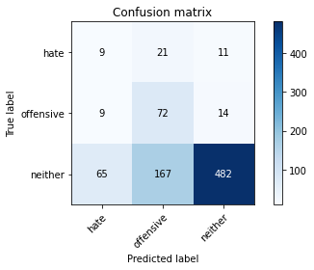

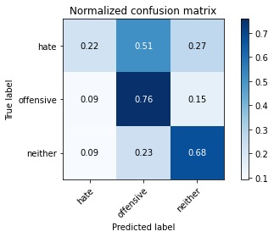

precision recall f1-score support

hate 0.11 0.22 0.15 41

offensive 0.28 0.76 0.41 95

neither 0.95 0.68 0.79 714

accuracy 0.66 850

macro avg 0.45 0.55 0.45 850

weighted avg 0.83 0.66 0.72 850

average eval_loss: 1.2235682372025452, accuracy: 0.6623529411764706

4 run......

training 1 epoch...

9.427374362945557 seconds used......

1 training finished! average train loss: 2.4757599896854825

total clf loss: 39.026916205883026 total adv loss: 25.050221651792526

evaluating...

Confusion matrix, without normalization

[[ 0 40 1]

[ 0 89 6]

[ 0 520 194]]

Normalized confusion matrix

[[0. 0.97560976 0.02439024]

[0. 0.93684211 0.06315789]

[0. 0.72829132 0.27170868]]

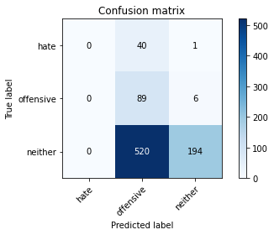

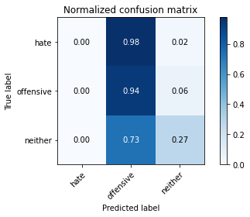

/opt/conda/lib/python3.7/site-packages/sklearn/metrics/_classification.py:1245: UndefinedMetricWarning: Precision and F-score are ill-defined and being set to 0.0 in labels with no predicted samples. Use `zero_division` parameter to control this behavior.

_warn_prf(average, modifier, msg_start, len(result))

/opt/conda/lib/python3.7/site-packages/sklearn/metrics/_classification.py:1245: UndefinedMetricWarning: Precision and F-score are ill-defined and being set to 0.0 in labels with no predicted samples. Use `zero_division` parameter to control this behavior.

_warn_prf(average, modifier, msg_start, len(result))

/opt/conda/lib/python3.7/site-packages/sklearn/metrics/_classification.py:1245: UndefinedMetricWarning: Precision and F-score are ill-defined and being set to 0.0 in labels with no predicted samples. Use `zero_division` parameter to control this behavior.

_warn_prf(average, modifier, msg_start, len(result))

precision recall f1-score support

hate 0.00 0.00 0.00 41

offensive 0.14 0.94 0.24 95

neither 0.97 0.27 0.42 714

accuracy 0.33 850

macro avg 0.37 0.40 0.22 850

weighted avg 0.83 0.33 0.38 850

average eval_loss: 0.9997968382613603, accuracy: 0.33294117647058824

training 2 epoch...

9.324895858764648 seconds used......

2 training finished! average train loss: 2.2013283173243203

total clf loss: 34.52154761552811 total adv loss: 22.363135814666748

evaluating...

Confusion matrix, without normalization

[[ 0 40 1]

[ 0 89 6]

[ 0 456 258]]

Normalized confusion matrix

[[0. 0.97560976 0.02439024]

[0. 0.93684211 0.06315789]

[0. 0.63865546 0.36134454]]

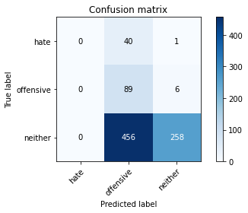

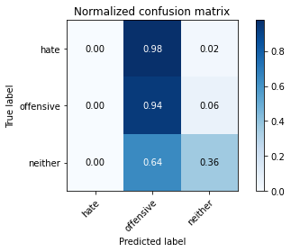

/opt/conda/lib/python3.7/site-packages/sklearn/metrics/_classification.py:1245: UndefinedMetricWarning: Precision and F-score are ill-defined and being set to 0.0 in labels with no predicted samples. Use `zero_division` parameter to control this behavior.

_warn_prf(average, modifier, msg_start, len(result))

/opt/conda/lib/python3.7/site-packages/sklearn/metrics/_classification.py:1245: UndefinedMetricWarning: Precision and F-score are ill-defined and being set to 0.0 in labels with no predicted samples. Use `zero_division` parameter to control this behavior.

_warn_prf(average, modifier, msg_start, len(result))

/opt/conda/lib/python3.7/site-packages/sklearn/metrics/_classification.py:1245: UndefinedMetricWarning: Precision and F-score are ill-defined and being set to 0.0 in labels with no predicted samples. Use `zero_division` parameter to control this behavior.

_warn_prf(average, modifier, msg_start, len(result))

precision recall f1-score support

hate 0.00 0.00 0.00 41

offensive 0.15 0.94 0.26 95

neither 0.97 0.36 0.53 714

accuracy 0.41 850

macro avg 0.38 0.43 0.26 850

weighted avg 0.83 0.41 0.47 850

average eval_loss: 1.0240167601163996, accuracy: 0.4082352941176471

training 3 epoch...

9.399461269378662 seconds used......

3 training finished! average train loss: 1.9600310292508867

total clf loss: 30.52833592891693 total adv loss: 20.016390591859818

evaluating...

Confusion matrix, without normalization

[[ 0 30 11]

[ 0 83 12]

[ 0 317 397]]

Normalized confusion matrix

[[0. 0.73170732 0.26829268]

[0. 0.87368421 0.12631579]

[0. 0.44397759 0.55602241]]

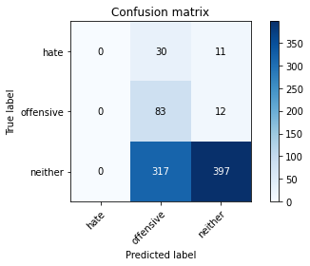

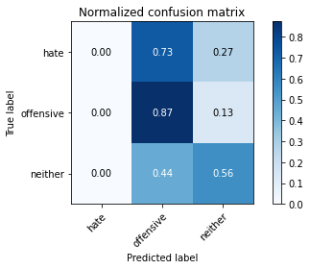

/opt/conda/lib/python3.7/site-packages/sklearn/metrics/_classification.py:1245: UndefinedMetricWarning: Precision and F-score are ill-defined and being set to 0.0 in labels with no predicted samples. Use `zero_division` parameter to control this behavior.

_warn_prf(average, modifier, msg_start, len(result))

/opt/conda/lib/python3.7/site-packages/sklearn/metrics/_classification.py:1245: UndefinedMetricWarning: Precision and F-score are ill-defined and being set to 0.0 in labels with no predicted samples. Use `zero_division` parameter to control this behavior.

_warn_prf(average, modifier, msg_start, len(result))

/opt/conda/lib/python3.7/site-packages/sklearn/metrics/_classification.py:1245: UndefinedMetricWarning: Precision and F-score are ill-defined and being set to 0.0 in labels with no predicted samples. Use `zero_division` parameter to control this behavior.

_warn_prf(average, modifier, msg_start, len(result))

precision recall f1-score support

hate 0.00 0.00 0.00 41

offensive 0.19 0.87 0.32 95

neither 0.95 0.56 0.70 714

accuracy 0.56 850

macro avg 0.38 0.48 0.34 850

weighted avg 0.82 0.56 0.62 850

average eval_loss: 0.9165597183759823, accuracy: 0.5647058823529412

training 4 epoch...

9.346229076385498 seconds used......

4 training finished! average train loss: 1.4417824281586542

total clf loss: 24.19689580798149 total adv loss: 13.853635892271996

evaluating...

Confusion matrix, without normalization

[[ 3 23 15]

[ 2 74 19]

[ 15 217 482]]

Normalized confusion matrix

[[0.07317073 0.56097561 0.36585366]

[0.02105263 0.77894737 0.2 ]

[0.0210084 0.30392157 0.67507003]]

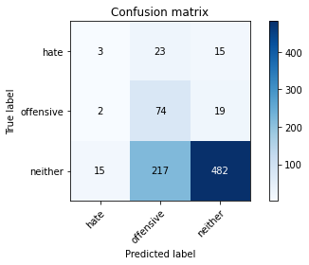

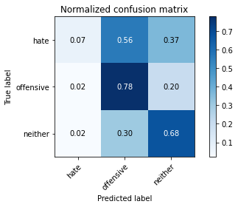

precision recall f1-score support

hate 0.15 0.07 0.10 41

offensive 0.24 0.78 0.36 95

neither 0.93 0.68 0.78 714

accuracy 0.66 850

macro avg 0.44 0.51 0.41 850

weighted avg 0.82 0.66 0.70 850

average eval_loss: 0.81075413403816, accuracy: 0.6576470588235294

training 5 epoch...

9.352161645889282 seconds used......

5 training finished! average train loss: 0.8354329533047147

total clf loss: 16.907099917531013 total adv loss: 6.584243305027485

evaluating...

Confusion matrix, without normalization

[[ 6 22 13]

[ 7 75 13]

[ 50 241 423]]

Normalized confusion matrix

[[0.14634146 0.53658537 0.31707317]

[0.07368421 0.78947368 0.13684211]

[0.07002801 0.33753501 0.59243697]]

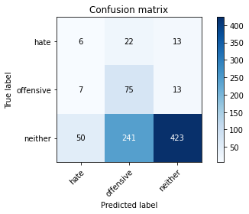

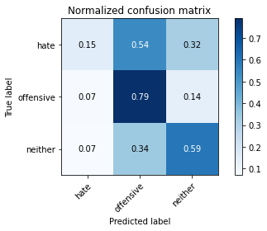

precision recall f1-score support

hate 0.10 0.15 0.12 41

offensive 0.22 0.79 0.35 95

neither 0.94 0.59 0.73 714

accuracy 0.59 850

macro avg 0.42 0.51 0.40 850

weighted avg 0.82 0.59 0.66 850

average eval_loss: 0.9788890311191248, accuracy: 0.5929411764705882

training 6 epoch...

9.343929052352905 seconds used......

6 training finished! average train loss: 0.6275161186026202

total clf loss: 12.890612296760082 total adv loss: 4.849983864463866

evaluating...

Confusion matrix, without normalization

[[ 7 18 16]

[ 11 58 26]

[ 65 124 525]]

Normalized confusion matrix

[[0.17073171 0.43902439 0.3902439 ]

[0.11578947 0.61052632 0.27368421]

[0.09103641 0.17366947 0.73529412]]

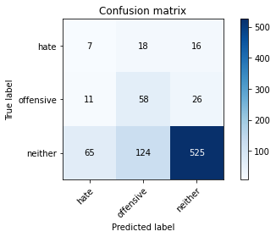

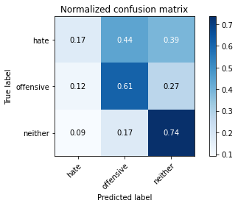

precision recall f1-score support

hate 0.08 0.17 0.11 41

offensive 0.29 0.61 0.39 95

neither 0.93 0.74 0.82 714

accuracy 0.69 850

macro avg 0.43 0.51 0.44 850

weighted avg 0.81 0.69 0.74 850

average eval_loss: 0.797228506484697, accuracy: 0.6941176470588235

training 7 epoch...

9.320959091186523 seconds used......

7 training finished! average train loss: 0.4358984861108992

total clf loss: 10.215982250869274 total adv loss: 2.7381816296838224

evaluating...

Confusion matrix, without normalization

[[ 7 22 12]

[ 9 75 11]

[ 71 225 418]]

Normalized confusion matrix

[[0.17073171 0.53658537 0.29268293]

[0.09473684 0.78947368 0.11578947]

[0.09943978 0.31512605 0.58543417]]

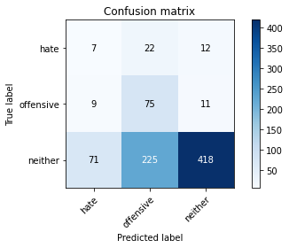

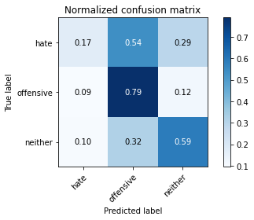

precision recall f1-score support

hate 0.08 0.17 0.11 41

offensive 0.23 0.79 0.36 95

neither 0.95 0.59 0.72 714

accuracy 0.59 850

macro avg 0.42 0.52 0.40 850

weighted avg 0.83 0.59 0.65 850

average eval_loss: 1.1790611461498017, accuracy: 0.5882352941176471

training 8 epoch...

9.441046953201294 seconds used......

8 training finished! average train loss: 0.222112992985381

total clf loss: 7.020900808274746 total adv loss: 0.487583504174836

evaluating...

Confusion matrix, without normalization

[[ 9 19 13]

[ 12 64 19]

[ 76 183 455]]

Normalized confusion matrix

[[0.2195122 0.46341463 0.31707317]

[0.12631579 0.67368421 0.2 ]

[0.10644258 0.25630252 0.6372549 ]]

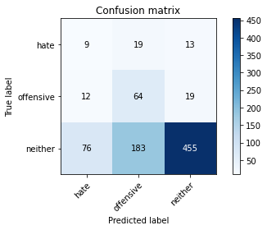

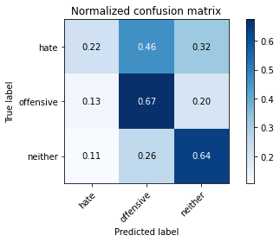

precision recall f1-score support

hate 0.09 0.22 0.13 41

offensive 0.24 0.67 0.35 95

neither 0.93 0.64 0.76 714

accuracy 0.62 850

macro avg 0.42 0.51 0.41 850

weighted avg 0.82 0.62 0.68 850

average eval_loss: 1.0608476506069648, accuracy: 0.6211764705882353

training 9 epoch...

9.264246702194214 seconds used......

9 training finished! average train loss: 0.14866277632407016

total clf loss: 5.244560529477894 total adv loss: 0.05364969289075816

evaluating...

Confusion matrix, without normalization

[[ 9 19 13]

[ 12 63 20]

[ 74 168 472]]

Normalized confusion matrix

[[0.2195122 0.46341463 0.31707317]

[0.12631579 0.66315789 0.21052632]

[0.10364146 0.23529412 0.66106443]]

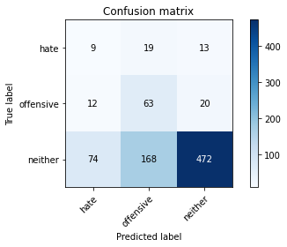

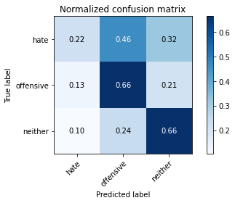

precision recall f1-score support

hate 0.09 0.22 0.13 41

offensive 0.25 0.66 0.37 95

neither 0.93 0.66 0.77 714

accuracy 0.64 850

macro avg 0.43 0.51 0.42 850

weighted avg 0.82 0.64 0.70 850

average eval_loss: 1.1054814530666484, accuracy: 0.64

training 10 epoch...

9.294032096862793 seconds used......

10 training finished! average train loss: 0.10827904349813859

total clf loss: 3.766919694840908 total adv loss: 0.06556292270897757

evaluating...

Confusion matrix, without normalization

[[ 12 19 10]

[ 15 62 18]

[ 99 167 448]]

Normalized confusion matrix

[[0.29268293 0.46341463 0.24390244]

[0.15789474 0.65263158 0.18947368]

[0.13865546 0.23389356 0.62745098]]

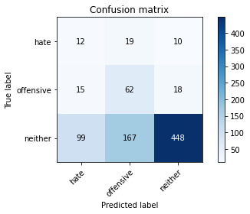

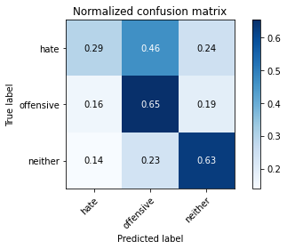

precision recall f1-score support

hate 0.10 0.29 0.14 41

offensive 0.25 0.65 0.36 95

neither 0.94 0.63 0.75 714

accuracy 0.61 850

macro avg 0.43 0.52 0.42 850

weighted avg 0.82 0.61 0.68 850

average eval_loss: 1.2548876238423725, accuracy: 0.6141176470588235

training 11 epoch...

9.305911540985107 seconds used......

11 training finished! average train loss: 0.07431817199620935

total clf loss: 2.622972683981061 total adv loss: 0.026240759378197254

evaluating...

Confusion matrix, without normalization

[[ 12 19 10]

[ 13 62 20]

[ 77 192 445]]

Normalized confusion matrix

[[0.29268293 0.46341463 0.24390244]

[0.13684211 0.65263158 0.21052632]

[0.10784314 0.26890756 0.6232493 ]]

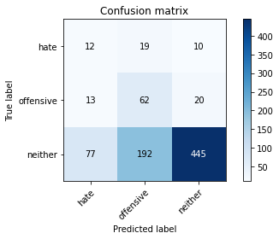

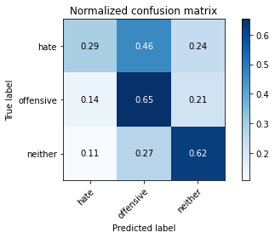

precision recall f1-score support

hate 0.12 0.29 0.17 41

offensive 0.23 0.65 0.34 95

neither 0.94 0.62 0.75 714

accuracy 0.61 850

macro avg 0.43 0.52 0.42 850

weighted avg 0.82 0.61 0.67 850

average eval_loss: 1.3444454436038815, accuracy: 0.6105882352941177

training 12 epoch...

9.325794696807861 seconds used......

12 training finished! average train loss: 0.045651385120840535

total clf loss: 1.6220867056399584 total adv loss: 0.010681582449251437

evaluating...

Confusion matrix, without normalization

[[ 15 18 8]

[ 17 61 17]

[116 161 437]]

Normalized confusion matrix

[[0.36585366 0.43902439 0.19512195]

[0.17894737 0.64210526 0.17894737]

[0.16246499 0.2254902 0.61204482]]

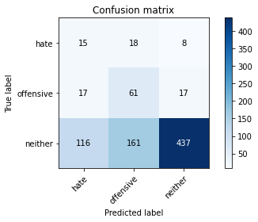

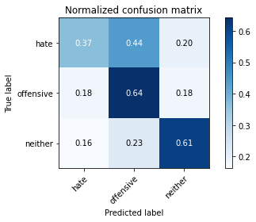

precision recall f1-score support

hate 0.10 0.37 0.16 41

offensive 0.25 0.64 0.36 95

neither 0.95 0.61 0.74 714

accuracy 0.60 850

macro avg 0.43 0.54 0.42 850

weighted avg 0.83 0.60 0.67 850

average eval_loss: 1.4096010582045067, accuracy: 0.6035294117647059

training 13 epoch...

9.369037389755249 seconds used......

13 training finished! average train loss: 0.038104072019147374

total clf loss: 1.2092670863494277 total adv loss: 0.08123976619390305

evaluating...

Confusion matrix, without normalization

[[ 10 25 6]

[ 9 78 8]

[ 84 250 380]]

Normalized confusion matrix

[[0.24390244 0.6097561 0.14634146]

[0.09473684 0.82105263 0.08421053]

[0.11764706 0.35014006 0.53221289]]

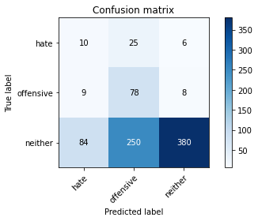

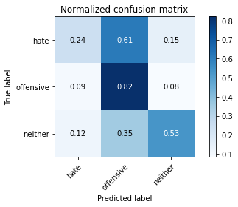

precision recall f1-score support

hate 0.10 0.24 0.14 41

offensive 0.22 0.82 0.35 95

neither 0.96 0.53 0.69 714

accuracy 0.55 850

macro avg 0.43 0.53 0.39 850

weighted avg 0.84 0.55 0.62 850

average eval_loss: 1.9726383819483047, accuracy: 0.5505882352941176

training 14 epoch...

9.327443361282349 seconds used......

14 training finished! average train loss: 0.07673735713534471

total clf loss: 1.7018891260959208 total adv loss: 0.5303278627216059

evaluating...

Confusion matrix, without normalization

[[ 14 22 5]

[ 17 68 10]

[163 167 384]]

Normalized confusion matrix

[[0.34146341 0.53658537 0.12195122]

[0.17894737 0.71578947 0.10526316]

[0.22829132 0.23389356 0.53781513]]

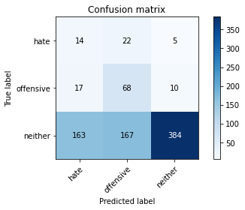

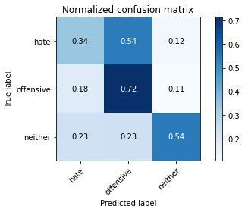

precision recall f1-score support

hate 0.07 0.34 0.12 41

offensive 0.26 0.72 0.39 95

neither 0.96 0.54 0.69 714

accuracy 0.55 850

macro avg 0.43 0.53 0.40 850

weighted avg 0.84 0.55 0.63 850

average eval_loss: 1.6031662525479184, accuracy: 0.548235294117647

training 15 epoch...

9.33145546913147 seconds used......

15 training finished! average train loss: 0.030223494356808562

total clf loss: 0.9721318166702986 total adv loss: 0.057956988810474286

evaluating...

Confusion matrix, without normalization

[[ 12 20 9]

[ 17 65 13]

[127 157 430]]

Normalized confusion matrix

[[0.29268293 0.48780488 0.2195122 ]

[0.17894737 0.68421053 0.13684211]

[0.17787115 0.21988796 0.6022409 ]]

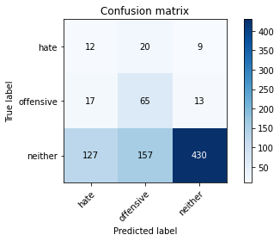

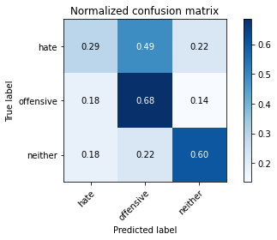

precision recall f1-score support

hate 0.08 0.29 0.12 41

offensive 0.27 0.68 0.39 95

neither 0.95 0.60 0.74 714

accuracy 0.60 850

macro avg 0.43 0.53 0.42 850

weighted avg 0.83 0.60 0.67 850

average eval_loss: 1.479753385103026, accuracy: 0.5964705882352941

training 16 epoch...

9.38171124458313 seconds used......

16 training finished! average train loss: 0.014770152577612963

total clf loss: 0.5225392584688962 total adv loss: 0.0045931177173770266

evaluating...

Confusion matrix, without normalization

[[ 13 16 12]

[ 15 59 21]

[105 127 482]]

Normalized confusion matrix

[[0.31707317 0.3902439 0.29268293]

[0.15789474 0.62105263 0.22105263]

[0.14705882 0.17787115 0.67507003]]

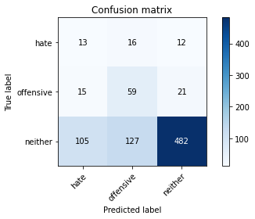

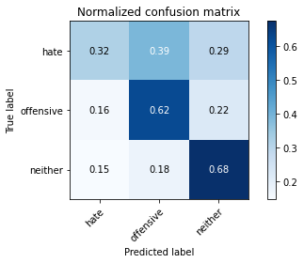

precision recall f1-score support

hate 0.10 0.32 0.15 41

offensive 0.29 0.62 0.40 95

neither 0.94 0.68 0.78 714

accuracy 0.65 850

macro avg 0.44 0.54 0.44 850

weighted avg 0.82 0.65 0.71 850

average eval_loss: 1.3344884766698923, accuracy: 0.6517647058823529

training 17 epoch...

9.304985046386719 seconds used......

17 training finished! average train loss: 0.00989994630476253

total clf loss: 0.3512216897215694 total adv loss: 0.0025881900669446622

evaluating...

Confusion matrix, without normalization

[[ 14 18 9]

[ 17 62 16]

[121 143 450]]

Normalized confusion matrix

[[0.34146341 0.43902439 0.2195122 ]

[0.17894737 0.65263158 0.16842105]

[0.16946779 0.20028011 0.6302521 ]]

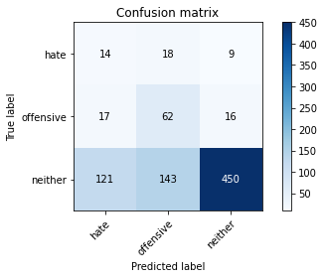

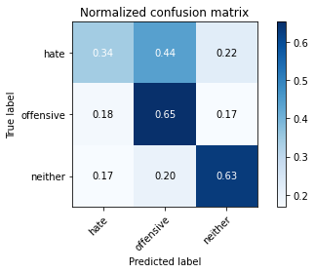

precision recall f1-score support

hate 0.09 0.34 0.15 41

offensive 0.28 0.65 0.39 95

neither 0.95 0.63 0.76 714

accuracy 0.62 850

macro avg 0.44 0.54 0.43 850

weighted avg 0.83 0.62 0.69 850

average eval_loss: 1.5163844336950503, accuracy: 0.6188235294117647

training 18 epoch...

9.340869903564453 seconds used......

18 training finished! average train loss: 0.006802862167306658

total clf loss: 0.23978154663927853 total adv loss: 0.002560745724622393

evaluating...

Confusion matrix, without normalization

[[ 12 19 10]

[ 15 63 17]

[114 147 453]]

Normalized confusion matrix

[[0.29268293 0.46341463 0.24390244]

[0.15789474 0.66315789 0.17894737]

[0.15966387 0.20588235 0.63445378]]

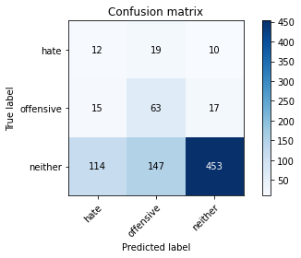

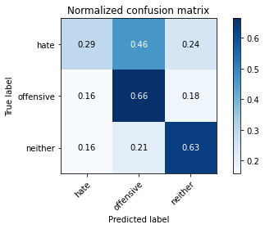

precision recall f1-score support

hate 0.09 0.29 0.13 41

offensive 0.28 0.66 0.39 95

neither 0.94 0.63 0.76 714

accuracy 0.62 850

macro avg 0.43 0.53 0.43 850

weighted avg 0.83 0.62 0.69 850

average eval_loss: 1.5422732143901114, accuracy: 0.6211764705882353

training 19 epoch...

9.314239025115967 seconds used......

19 training finished! average train loss: 0.006455634707688457

total clf loss: 0.22608764027245343 total adv loss: 0.0031576056435369537

evaluating...

Confusion matrix, without normalization

[[ 13 19 9]

[ 15 63 17]

[113 145 456]]

Normalized confusion matrix

[[0.31707317 0.46341463 0.2195122 ]

[0.15789474 0.66315789 0.17894737]

[0.15826331 0.20308123 0.63865546]]

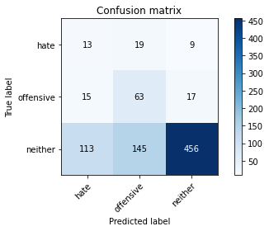

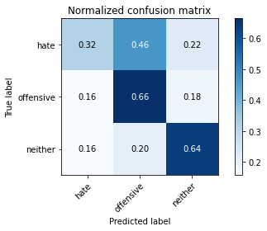

precision recall f1-score support

hate 0.09 0.32 0.14 41

offensive 0.28 0.66 0.39 95

neither 0.95 0.64 0.76 714

accuracy 0.63 850

macro avg 0.44 0.54 0.43 850

weighted avg 0.83 0.63 0.69 850

average eval_loss: 1.5634462548809689, accuracy: 0.6258823529411764

training 20 epoch...

9.350275993347168 seconds used......

20 training finished! average train loss: 0.005663093459184488

total clf loss: 0.18436371989082545 total adv loss: 0.00975382319666096

evaluating...

Confusion matrix, without normalization

[[ 12 22 7]

[ 11 73 11]

[ 94 188 432]]

Normalized confusion matrix

[[0.29268293 0.53658537 0.17073171]

[0.11578947 0.76842105 0.11578947]

[0.13165266 0.26330532 0.60504202]]

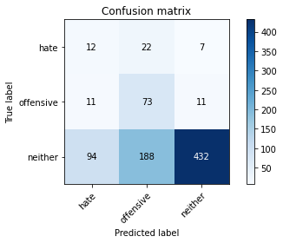

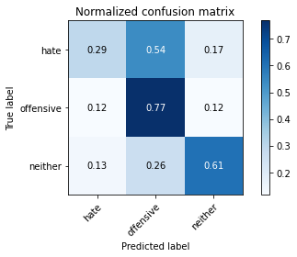

precision recall f1-score support

hate 0.10 0.29 0.15 41

offensive 0.26 0.77 0.39 95

neither 0.96 0.61 0.74 714

accuracy 0.61 850

macro avg 0.44 0.56 0.43 850

weighted avg 0.84 0.61 0.67 850

average eval_loss: 1.811250686428921, accuracy: 0.6082352941176471

5 run......

training 1 epoch...

9.265691757202148 seconds used......

1 training finished! average train loss: 2.4593389299180775

total clf loss: 38.941817462444305 total adv loss: 24.79719227552414

evaluating...

Confusion matrix, without normalization

[[ 0 38 3]

[ 0 65 30]

[ 0 292 422]]

Normalized confusion matrix

[[0. 0.92682927 0.07317073]

[0. 0.68421053 0.31578947]

[0. 0.40896359 0.59103641]]

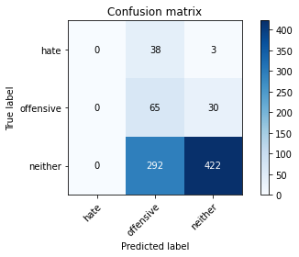

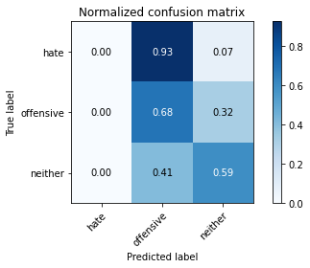

/opt/conda/lib/python3.7/site-packages/sklearn/metrics/_classification.py:1245: UndefinedMetricWarning: Precision and F-score are ill-defined and being set to 0.0 in labels with no predicted samples. Use `zero_division` parameter to control this behavior.

_warn_prf(average, modifier, msg_start, len(result))

/opt/conda/lib/python3.7/site-packages/sklearn/metrics/_classification.py:1245: UndefinedMetricWarning: Precision and F-score are ill-defined and being set to 0.0 in labels with no predicted samples. Use `zero_division` parameter to control this behavior.

_warn_prf(average, modifier, msg_start, len(result))

/opt/conda/lib/python3.7/site-packages/sklearn/metrics/_classification.py:1245: UndefinedMetricWarning: Precision and F-score are ill-defined and being set to 0.0 in labels with no predicted samples. Use `zero_division` parameter to control this behavior.

_warn_prf(average, modifier, msg_start, len(result))

precision recall f1-score support

hate 0.00 0.00 0.00 41

offensive 0.16 0.68 0.27 95

neither 0.93 0.59 0.72 714

accuracy 0.57 850

macro avg 0.36 0.43 0.33 850

weighted avg 0.80 0.57 0.64 850

average eval_loss: 0.9245386886042218, accuracy: 0.5729411764705883

training 2 epoch...

9.334172248840332 seconds used......

2 training finished! average train loss: 2.128990630308787

total clf loss: 34.017906188964844 total adv loss: 21.31287783384323

evaluating...

Confusion matrix, without normalization

[[ 0 40 1]

[ 0 89 6]

[ 1 434 279]]

Normalized confusion matrix

[[0. 0.97560976 0.02439024]

[0. 0.93684211 0.06315789]

[0.00140056 0.60784314 0.3907563 ]]

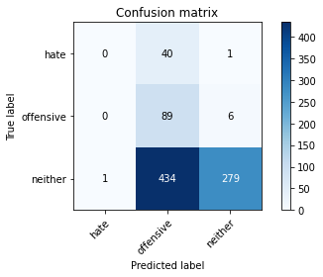

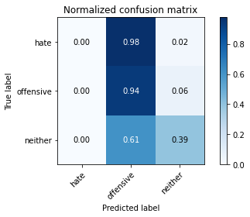

precision recall f1-score support

hate 0.00 0.00 0.00 41

offensive 0.16 0.94 0.27 95

neither 0.98 0.39 0.56 714

accuracy 0.43 850

macro avg 0.38 0.44 0.28 850

weighted avg 0.84 0.43 0.50 850

average eval_loss: 0.9573742310668147, accuracy: 0.4329411764705882

training 3 epoch...

9.442347764968872 seconds used......

3 training finished! average train loss: 1.8718836439980402

total clf loss: 29.842346847057343 total adv loss: 18.772732093930244

evaluating...

Confusion matrix, without normalization

[[ 1 24 16]

[ 0 71 24]

[ 6 196 512]]

Normalized confusion matrix

[[0.02439024 0.58536585 0.3902439 ]

[0. 0.74736842 0.25263158]

[0.00840336 0.2745098 0.71708683]]

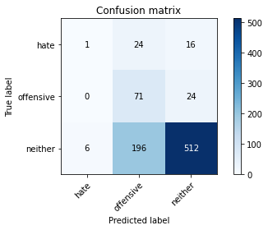

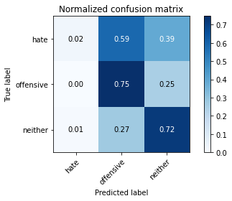

precision recall f1-score support

hate 0.14 0.02 0.04 41

offensive 0.24 0.75 0.37 95

neither 0.93 0.72 0.81 714

accuracy 0.69 850

macro avg 0.44 0.50 0.41 850

weighted avg 0.81 0.69 0.72 850

average eval_loss: 0.785298518663229, accuracy: 0.6870588235294117

training 4 epoch...

9.316985607147217 seconds used......

4 training finished! average train loss: 1.2063924372196198

total clf loss: 22.670854300260544 total adv loss: 10.379636771976948

evaluating...

Confusion matrix, without normalization

[[ 2 25 14]

[ 4 69 22]

[ 12 212 490]]

Normalized confusion matrix

[[0.04878049 0.6097561 0.34146341]

[0.04210526 0.72631579 0.23157895]

[0.01680672 0.29691877 0.68627451]]

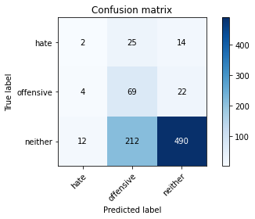

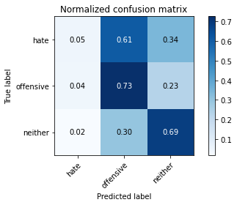

precision recall f1-score support

hate 0.11 0.05 0.07 41

offensive 0.23 0.73 0.34 95

neither 0.93 0.69 0.79 714

accuracy 0.66 850

macro avg 0.42 0.49 0.40 850

weighted avg 0.81 0.66 0.71 850

average eval_loss: 0.8145443039058253, accuracy: 0.66

training 5 epoch...

9.339357376098633 seconds used......

5 training finished! average train loss: 0.7959779252608618

total clf loss: 16.66867697238922 total adv loss: 5.9932641685009

evaluating...

Confusion matrix, without normalization

[[ 10 15 16]

[ 6 56 33]

[ 32 149 533]]

Normalized confusion matrix

[[0.24390244 0.36585366 0.3902439 ]

[0.06315789 0.58947368 0.34736842]

[0.04481793 0.20868347 0.7464986 ]]

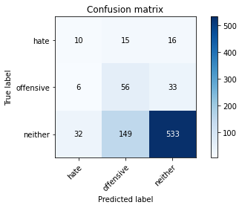

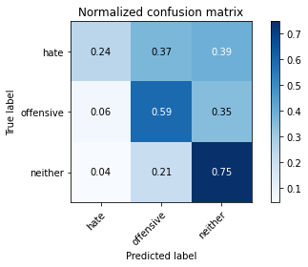

precision recall f1-score support

hate 0.21 0.24 0.22 41

offensive 0.25 0.59 0.36 95

neither 0.92 0.75 0.82 714

accuracy 0.70 850

macro avg 0.46 0.53 0.47 850

weighted avg 0.81 0.70 0.74 850

average eval_loss: 0.7433396954695846, accuracy: 0.7047058823529412

training 6 epoch...

9.319660425186157 seconds used......

6 training finished! average train loss: 0.44670557727416355

total clf loss: 11.942106187343597 total adv loss: 2.0696473475545645

evaluating...

Confusion matrix, without normalization

[[ 9 10 22]

[ 8 41 46]

[ 28 74 612]]

Normalized confusion matrix

[[0.2195122 0.24390244 0.53658537]

[0.08421053 0.43157895 0.48421053]

[0.03921569 0.10364146 0.85714286]]

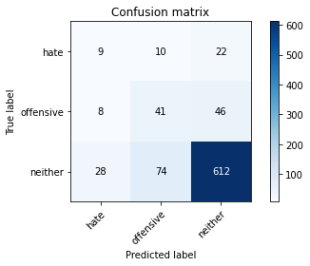

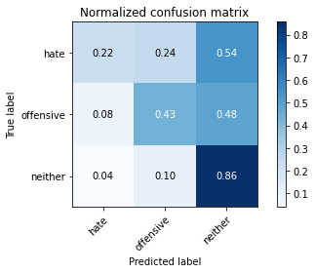

precision recall f1-score support

hate 0.20 0.22 0.21 41

offensive 0.33 0.43 0.37 95

neither 0.90 0.86 0.88 714

accuracy 0.78 850

macro avg 0.48 0.50 0.49 850

weighted avg 0.80 0.78 0.79 850

average eval_loss: 0.6282476931810379, accuracy: 0.7788235294117647

training 7 epoch...

9.30276107788086 seconds used......

7 training finished! average train loss: 0.4090119478189283

total clf loss: 9.648583628237247 total adv loss: 2.537923273514025

evaluating...

Confusion matrix, without normalization

[[ 9 17 15]

[ 13 61 21]

[ 65 147 502]]

Normalized confusion matrix

[[0.2195122 0.41463415 0.36585366]

[0.13684211 0.64210526 0.22105263]

[0.09103641 0.20588235 0.70308123]]

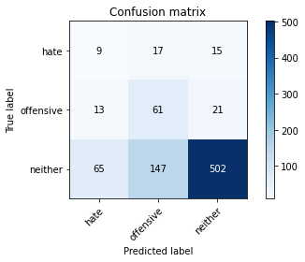

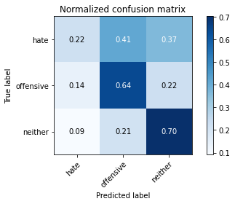

precision recall f1-score support

hate 0.10 0.22 0.14 41

offensive 0.27 0.64 0.38 95

neither 0.93 0.70 0.80 714

accuracy 0.67 850

macro avg 0.44 0.52 0.44 850

weighted avg 0.82 0.67 0.72 850

average eval_loss: 0.8537032165846159, accuracy: 0.6729411764705883

training 8 epoch...

9.396210670471191 seconds used......

8 training finished! average train loss: 0.20531484960681862

total clf loss: 7.003373205661774 total adv loss: 0.19398063616245054

evaluating...

Confusion matrix, without normalization

[[ 11 21 9]

[ 15 72 8]

[ 75 216 423]]

Normalized confusion matrix

[[0.26829268 0.51219512 0.2195122 ]

[0.15789474 0.75789474 0.08421053]

[0.10504202 0.30252101 0.59243697]]

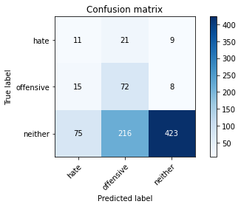

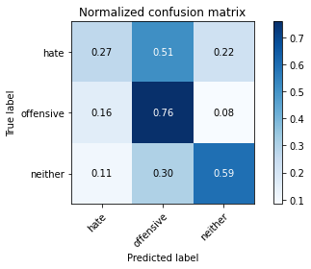

precision recall f1-score support

hate 0.11 0.27 0.15 41

offensive 0.23 0.76 0.36 95

neither 0.96 0.59 0.73 714

accuracy 0.60 850

macro avg 0.43 0.54 0.41 850

weighted avg 0.84 0.60 0.66 850

average eval_loss: 1.1800507055812104, accuracy: 0.5952941176470589

training 9 epoch...

9.309850215911865 seconds used......

9 training finished! average train loss: 0.15449790542738306

total clf loss: 5.482618533074856 total adv loss: 0.039653009465837386

evaluating...

Confusion matrix, without normalization

[[ 13 17 11]

[ 16 64 15]

[ 90 151 473]]

Normalized confusion matrix

[[0.31707317 0.41463415 0.26829268]

[0.16842105 0.67368421 0.15789474]

[0.12605042 0.21148459 0.66246499]]

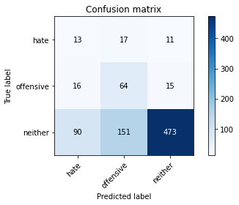

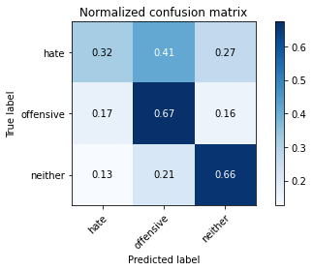

precision recall f1-score support

hate 0.11 0.32 0.16 41

offensive 0.28 0.67 0.39 95

neither 0.95 0.66 0.78 714

accuracy 0.65 850

macro avg 0.44 0.55 0.44 850

weighted avg 0.83 0.65 0.71 850

average eval_loss: 1.046789130672466, accuracy: 0.6470588235294118

training 10 epoch...

9.360800743103027 seconds used......

10 training finished! average train loss: 0.11244839663979495

total clf loss: 4.030347828986123 total adv loss: 0.008897239219550102

evaluating...

Confusion matrix, without normalization

[[ 9 17 15]

[ 14 66 15]

[ 67 154 493]]

Normalized confusion matrix

[[0.2195122 0.41463415 0.36585366]

[0.14736842 0.69473684 0.15789474]

[0.09383754 0.21568627 0.69047619]]

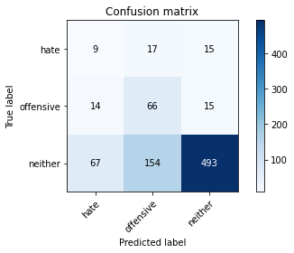

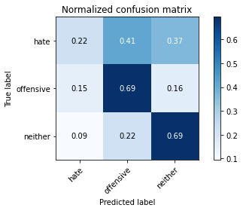

precision recall f1-score support

hate 0.10 0.22 0.14 41

offensive 0.28 0.69 0.40 95

neither 0.94 0.69 0.80 714

accuracy 0.67 850

macro avg 0.44 0.53 0.44 850

weighted avg 0.83 0.67 0.72 850

average eval_loss: 1.04382703864817, accuracy: 0.668235294117647

training 11 epoch...

9.320904970169067 seconds used......

11 training finished! average train loss: 0.08108593238931563

total clf loss: 2.8667568434029818 total adv loss: 0.02616836823108315

evaluating...

Confusion matrix, without normalization

[[ 16 16 9]

[ 20 66 9]

[128 155 431]]

Normalized confusion matrix

[[0.3902439 0.3902439 0.2195122 ]

[0.21052632 0.69473684 0.09473684]

[0.17927171 0.21708683 0.60364146]]

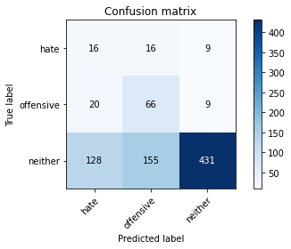

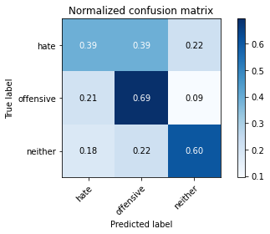

precision recall f1-score support

hate 0.10 0.39 0.16 41

offensive 0.28 0.69 0.40 95

neither 0.96 0.60 0.74 714

accuracy 0.60 850

macro avg 0.45 0.56 0.43 850

weighted avg 0.84 0.60 0.67 850

average eval_loss: 1.2808261821696232, accuracy: 0.6035294117647059

training 12 epoch...

9.313215017318726 seconds used......

12 training finished! average train loss: 0.05107045473737849

total clf loss: 1.8314987877383828 total adv loss: 0.00351878997116728

evaluating...

Confusion matrix, without normalization

[[ 16 16 9]

[ 20 65 10]

[120 160 434]]

Normalized confusion matrix

[[0.3902439 0.3902439 0.2195122 ]

[0.21052632 0.68421053 0.10526316]

[0.16806723 0.22408964 0.60784314]]

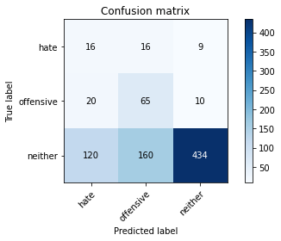

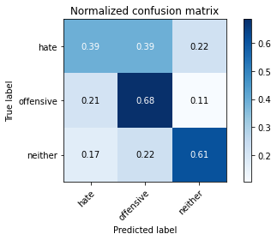

precision recall f1-score support

hate 0.10 0.39 0.16 41

offensive 0.27 0.68 0.39 95

neither 0.96 0.61 0.74 714

accuracy 0.61 850

macro avg 0.44 0.56 0.43 850

weighted avg 0.84 0.61 0.68 850

average eval_loss: 1.3466136475028687, accuracy: 0.6058823529411764

training 13 epoch...

9.40678358078003 seconds used......

13 training finished! average train loss: 0.044601310070397124

total clf loss: 1.601173697039485 total adv loss: 0.002236729855667363

evaluating...

Confusion matrix, without normalization

[[ 14 15 12]

[ 18 65 12]

[ 98 149 467]]

Normalized confusion matrix

[[0.34146341 0.36585366 0.29268293]

[0.18947368 0.68421053 0.12631579]

[0.1372549 0.20868347 0.65406162]]

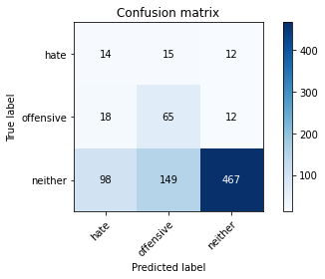

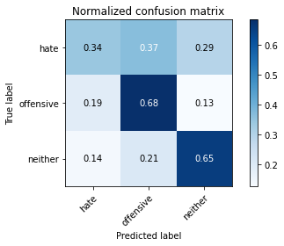

precision recall f1-score support

hate 0.11 0.34 0.16 41

offensive 0.28 0.68 0.40 95

neither 0.95 0.65 0.78 714

accuracy 0.64 850

macro avg 0.45 0.56 0.45 850

weighted avg 0.84 0.64 0.70 850

average eval_loss: 1.2679775944196208, accuracy: 0.6423529411764706

training 14 epoch...

9.325939655303955 seconds used......

14 training finished! average train loss: 0.023266843740000494

total clf loss: 0.831263757776469 total adv loss: 0.0031713098360341974

evaluating...

Confusion matrix, without normalization

[[ 18 15 8]

[ 19 65 11]

[124 156 434]]

Normalized confusion matrix

[[0.43902439 0.36585366 0.19512195]

[0.2 0.68421053 0.11578947]

[0.17366947 0.21848739 0.60784314]]

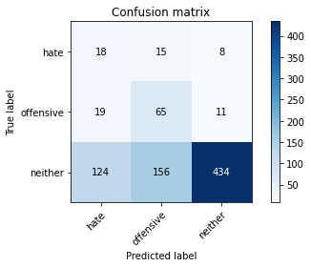

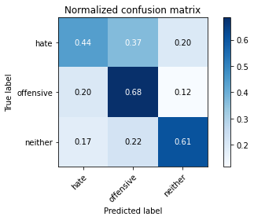

precision recall f1-score support

hate 0.11 0.44 0.18 41

offensive 0.28 0.68 0.39 95

neither 0.96 0.61 0.74 714

accuracy 0.61 850

macro avg 0.45 0.58 0.44 850

weighted avg 0.84 0.61 0.68 850

average eval_loss: 1.4836867504514928, accuracy: 0.6082352941176471

training 15 epoch...

9.450371026992798 seconds used......

15 training finished! average train loss: 0.0193450059935761

total clf loss: 0.6697751588653773 total adv loss: 0.013322528345270257

evaluating...

Confusion matrix, without normalization

[[ 15 15 11]

[ 19 64 12]

[107 143 464]]

Normalized confusion matrix

[[0.36585366 0.36585366 0.26829268]

[0.2 0.67368421 0.12631579]

[0.14985994 0.20028011 0.64985994]]

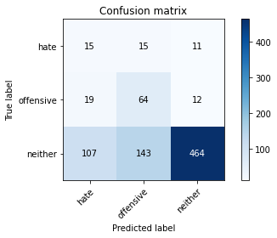

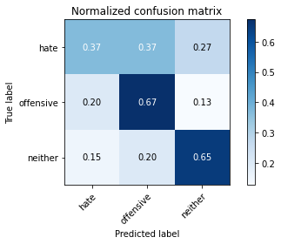

precision recall f1-score support

hate 0.11 0.37 0.16 41

offensive 0.29 0.67 0.40 95

neither 0.95 0.65 0.77 714

accuracy 0.64 850

macro avg 0.45 0.56 0.45 850

weighted avg 0.84 0.64 0.70 850

average eval_loss: 1.3980151649434553, accuracy: 0.6388235294117647

training 16 epoch...

9.32241439819336 seconds used......

16 training finished! average train loss: 0.012482986636718528

total clf loss: 0.4473203453235328 total adv loss: 0.0010335863180443994

evaluating...

Confusion matrix, without normalization

[[ 16 15 10]

[ 19 65 11]

[111 160 443]]

Normalized confusion matrix

[[0.3902439 0.36585366 0.24390244]

[0.2 0.68421053 0.11578947]

[0.15546218 0.22408964 0.62044818]]

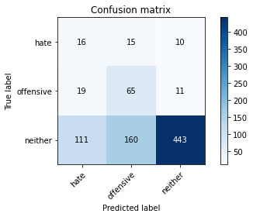

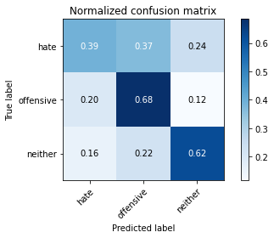

precision recall f1-score support

hate 0.11 0.39 0.17 41

offensive 0.27 0.68 0.39 95

neither 0.95 0.62 0.75 714

accuracy 0.62 850

macro avg 0.45 0.56 0.44 850

weighted avg 0.84 0.62 0.68 850

average eval_loss: 1.551421765801172, accuracy: 0.6164705882352941

training 17 epoch...

9.299628973007202 seconds used......

17 training finished! average train loss: 0.009283006113643447

total clf loss: 0.3325354536063969 total adv loss: 0.0008263831414296874

evaluating...

Confusion matrix, without normalization

[[ 14 15 12]

[ 18 65 12]

[103 148 463]]

Normalized confusion matrix

[[0.34146341 0.36585366 0.29268293]

[0.18947368 0.68421053 0.12631579]

[0.1442577 0.20728291 0.64845938]]

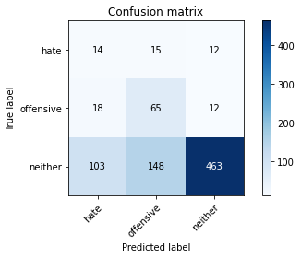

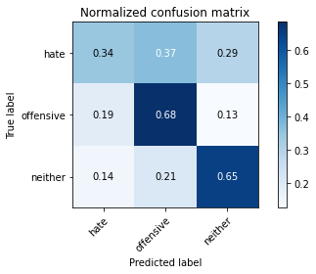

precision recall f1-score support

hate 0.10 0.34 0.16 41

offensive 0.29 0.68 0.40 95

neither 0.95 0.65 0.77 714

accuracy 0.64 850

macro avg 0.45 0.56 0.44 850

weighted avg 0.84 0.64 0.70 850

average eval_loss: 1.4695952301520074, accuracy: 0.6376470588235295

training 18 epoch...

9.325119018554688 seconds used......

18 training finished! average train loss: 0.007612381699598498

total clf loss: 0.27086700964719057 total adv loss: 0.0015893647175744263

evaluating...

Confusion matrix, without normalization

[[ 15 17 9]

[ 18 66 11]

[102 173 439]]

Normalized confusion matrix

[[0.36585366 0.41463415 0.2195122 ]

[0.18947368 0.69473684 0.11578947]

[0.14285714 0.24229692 0.61484594]]

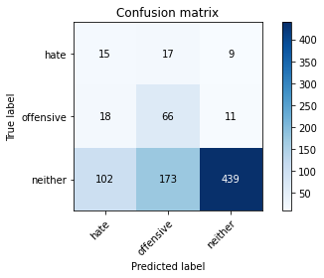

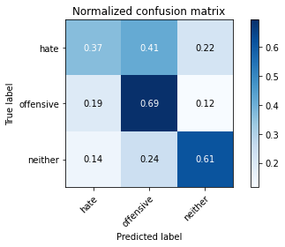

precision recall f1-score support

hate 0.11 0.37 0.17 41

offensive 0.26 0.69 0.38 95

neither 0.96 0.61 0.75 714

accuracy 0.61 850

macro avg 0.44 0.56 0.43 850

weighted avg 0.84 0.61 0.68 850

average eval_loss: 1.6459983836339658, accuracy: 0.611764705882353

training 19 epoch...

9.259625911712646 seconds used......

19 training finished! average train loss: 0.006082454224168841

total clf loss: 0.21823541179765016 total adv loss: 0.00036646972591825033

evaluating...

Confusion matrix, without normalization

[[ 15 15 11]

[ 18 65 12]

[ 95 165 454]]

Normalized confusion matrix

[[0.36585366 0.36585366 0.26829268]

[0.18947368 0.68421053 0.12631579]

[0.13305322 0.23109244 0.63585434]]

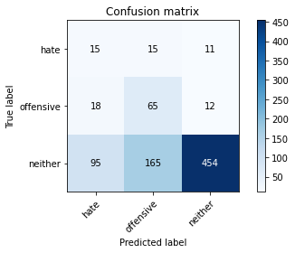

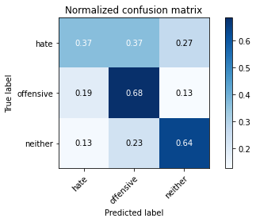

precision recall f1-score support

hate 0.12 0.37 0.18 41

offensive 0.27 0.68 0.38 95

neither 0.95 0.64 0.76 714

accuracy 0.63 850

macro avg 0.44 0.56 0.44 850

weighted avg 0.83 0.63 0.69 850

average eval_loss: 1.591328179225499, accuracy: 0.6282352941176471

training 20 epoch...

9.398074865341187 seconds used......

20 training finished! average train loss: 0.00550502506020065

total clf loss: 0.19751745311077684 total adv loss: 0.0003317239689977214

evaluating...

Confusion matrix, without normalization

[[ 15 15 11]

[ 20 63 12]

[109 142 463]]

Normalized confusion matrix

[[0.36585366 0.36585366 0.26829268]

[0.21052632 0.66315789 0.12631579]

[0.15266106 0.19887955 0.64845938]]

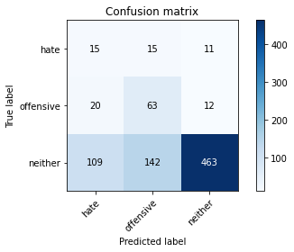

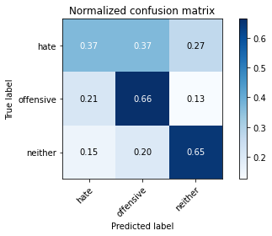

precision recall f1-score support

hate 0.10 0.37 0.16 41

offensive 0.29 0.66 0.40 95

neither 0.95 0.65 0.77 714

accuracy 0.64 850

macro avg 0.45 0.56 0.44 850

weighted avg 0.84 0.64 0.70 850

average eval_loss: 1.54440644455987, accuracy: 0.6364705882352941